**CA674 Cloud Architecture MCM – Project**

Bharathvaj Devarajan

16212388

**Abstract**

The project aims at doing a comparative study between various open source IaaS (Infrastructure as a Service) cloud platforms by developing and deploying an application over two virtual cloud infrastructures built using OpenStack and OpenNebula and analyse the results in terms of:

* Challenges in setting up the infrastructure
* Pros and Cons of using OpenStack/OpenNebula
* Interoperability concerns
* Challenges in deploying the application to cloud

With the results, we expect to gain insights for understanding the key aspects of cloud architecture and to study the basic problems which people are faced with while setting up the infrastructure. We hope to make use of these results to provide alternatives/improvements to the current schema of operation by comparing it with similar OSS solutions.

**Infrastructure as a Service**

IaaS is a cloud solution which provides a virtualized IT environment over the internet, which includes storage(SDS), computing and networks(SDN).

Benefits:

* Less capital cost as we don’t have to set up a physical infrastructure.
* Low maintenance as the maintenance part is usually taken care by the cloud provider and frequent updates and patches are provided for the virtual resources.
* Highly Scalable, as we can add/remove virtual resources as per demand.

**Application Details**

We would be implementing a chat application (DCU chat) prototype for DCU students and staff for communication and deploy the same over two different cloud platforms to compare the results. We would be using OpenStack and OpenNebula to set up the infrastructure required to host the application.

We would also compare and review the following IaaS based open source software/platform:

* OpenStack
* CloudStack
* Eucalyptus
* OpenNebula

**Individual Evaluation**

**OpenStack**

OpenStack is an open source cloud software solution which was started in 2010 as a joint project between NASA and Rackspace. It is primarily focussed on delivering Infrastructure as a Service (however, it is continuously evolving, broadening its scope beyond IaaS). It makes use of various core projects which are already in production to provide solutions to manage to compute, storage, and networking, this is made possible through Restful APIs which provide a common means of communication between various projects within OpenStack. All API’s developed in OpenStack are RESTful, which means that they provide a uniform access which is useful in a development perspective as the same standards are being used throughout. Apart from the core projects, there are also some useful non-core projects which can be leveraged while building a cloud platform.

**Architecture**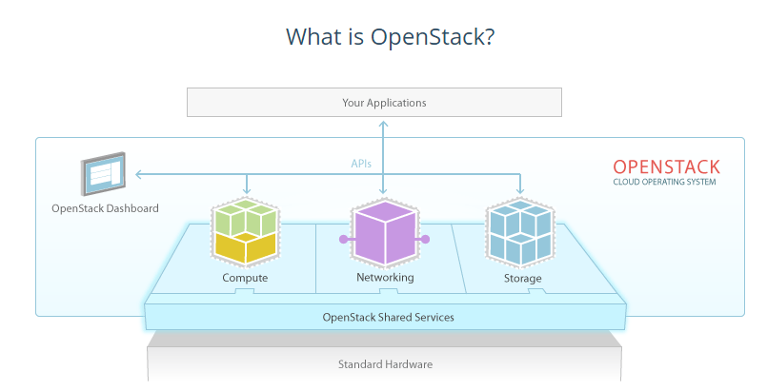

**(Image Source:** [**https://www.packtpub.com/books/content/virtualization**](https://www.packtpub.com/books/content/virtualization)**)**

**Compute**

NASA contributed their Nebula platform, which later developed into Nova project. Nova is responsible for managing the compute instance lifecycle. It is to be noted that Nova is not a hypervisor but it can integrate with many common hypervisors, such as Xen and KVM, it acts as an interface to hypervisors and gives us the flexibility to use OpenStack no matter what OS we are using. To achieve this Nova installs an agent to the hypervisor so that it is supported in the OpenStack environment. It is also responsible for spawning, scheduling and decommissioning of virtual machines on demand.

**Networking**

Neutron project provides Software Defined Networking to the cloud. It uses a pluggable architecture that supports numerous vendors and technologies, it also provides an API to allow users to define their own networks. Neutron is an essential component in the cloud set-up using OpenStack as the networks in the underlay and overlay may differ, i.e. we may need two machines which are connected to two different physical networks in the underlay to work in the same logical unit in the overlay, in such cases neutron can be used to create the SDN.

**Storage**

For Storage, OpenStack has two different flavours, object storage and block storage.

**Swift**

The swift project was designed to provide binary object storage in a distributed, replicated way. It basically breaks the file into fragments and stores them across different servers and it also replicates the data over multiple servers thus ensuring that the data is saved in a consistent manner. Swift also has an algorithm (RESTful API’s) in place to return the exact data whenever the application requests it and since RESTful API is the native language of OpenStack, and that makes Swift the native choice for object storage in OpenStack.

Swift is particularly useful for scalability purpose as it is very easy to add/remove servers due to its storage replication property.

**Cinder**

Cinder is another means of data storage; it is based on the principle of providing persistent storage to instances. As Instance storage is ephemeral the Cinder application allows administrators to attach additional persistent block devices to the instances. With Cinder, we have the option of choosing either Switch or Ceph as backend storage.

**OpenStack Dashboard**

OpenStack uses Horizon to provide a web interface for managing the instances and other activities such as assigning IP address and configuring access, it is a very important tool and is seen in most OpenStack deployments as it acts as an alternative to using the command prompt. Although it is not a core project it has been adopted by 86 % of all OpenStack clouds as it is an ideal platform for end-user self-management.

**OpenStack shared services**

**Image Service**

Glance project is used to store and retrieve virtual machine disk images. When Nova provisions an instance, it makes use of Glance to retrieve the image. For scalability Glance, can use either Swift or Ceph as backend. Glance makes use of RESTful API to query VM image metadata as well as retrieval of the actual image.

**Identity Service**

Keystone Identity is a core element in OpenStack and is used for providing authentication and authorization, it is also responsible for listing all current services and endpoints.

Keystone is also responsible for creating users and roles which are then assigned to projects(tenants).

It is the central repository for all services and endpoints and it uses MariaDB as default database to store information although other databases can also be used.

**OpenNebula:**

OpenNebula is an open source cloud software which was started in 2005 and was released under Apache. Its main aim is to deliver Infrastructure as a service but it also provides other features like integration, management, scalability, security, and accounting. OpenNebula is a simple yet very powerful in providing the solution in the virtualized data centre management. It is flexible in combining the advanced features with the existing virtualization technologies. It supports both private and hybrid cloud with the help of a virtualization tool in managing the local virtual infrastructure. It is platform independent and provides the support for different hypervisors, storage, and networking resources. The architecture of the OpenNebula is so extensible that it allows the choice of standards and cloud interface in building the customised cloud service.

**Architecture:**

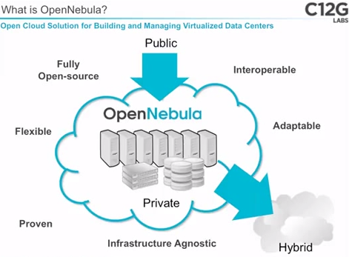

(Image Source: http://www.slideshare.net/opennebula/open-nebula-open-source-solution-for-data-center-virtualization)

**OpenNebula Components:**

* **Front-end –** The user creates the VMware using the front-end and the administration work is maintained with the help of the cloud operation centre. We can also use the front end to create the cloud networks and put the cloud into production operation. It contains the operation centre interface which controls the server nodes with the help of SSH access.
* **Host –** A host is a physical machine which runs a hypervisor. It can be installed on any Linux based system.
* **Cluster –**  cluster consists of Pool of server nodes. It is also called as the working node where we deploy the virtual machine. All the servers are connected through switches so that the data can be migrated easily and without delay. In short, we can say clusters are mainly used for load balancing through which we can achieve high availability and high-performance computing.
* **Data storage –**  It is a storage medium which is used as a disk images repository or to hold the images for running VMs.
* **Sunstone –**  It is the new operation centre of OpenNebula, a GUI for administration work and users and it also simplifies the management operations in the hybrid and private cloud infrastructure. Once the OpenNebula is installed then it is very easy to install the Sunstone with the help of few packages.

**OpenNebula Vs OpenStack**

|  |  |  |
| --- | --- | --- |
| **Category** | **OpenNebula** | **OpenStack** |
| **APIs and Interfaces** | It uses OCCI (Open Cloud Computing Interface) and EC2 APIs. | The API used by OpenStack is NOVA which is compatible with EC2(Elastic Computing Cloud) and S3 Amazon Web Service. |
| **Production Readiness** | It will be enterprise ready and we will be getting the support directly from the developers. | It is only available through Several Vendor specific tasks. |
| **Programming Language** | Java and Ruby | Python |
| **Networking model** | VLAN | Flat, Flat DHCP, VLAN DHCP |

**Experimental Evaluation**

**OpenStack Deployment**

There are essentially two means to try OpenStack: -

**1. Public Clouds on the Marketplace:**

This is a paid service using which we can try the OpenStack public clouds in production across the world.

**2. Deploying a local Development environment: devstack.org**

DevStack is basically a collection of scripts used to set up a complete OpenStack environment, it is cloned from gitmaster to incorporate all the latest features of OpenStack. It is primarily used by developers and potential users who tend to have a look and feel of OpenStack, the advantage of using this method is that we can run OpenStack on our laptops.

**Setting up OpenStack**

OpenStack supported by Linux based OS (Ubuntu 14.04/16.04, Fedora 23/24, CentOS/RHEL 7, as well as Debian and OpenSUSE), so the first step is to ensure system prerequisites:

* Once Linux is setup, open Terminal and install git using the command

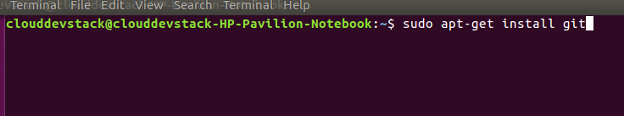

* After Git is installed, clone DevStack from git master, this will clone the DevStack scripts into the computer.

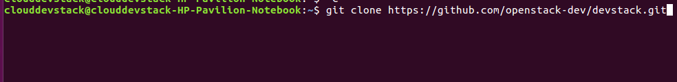

* Once the cloning is successful create a local configuration file inside devstack folder, in the terminal copy directory onto Devstack and run ./stack.sh command to run the installation

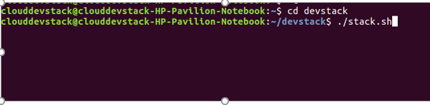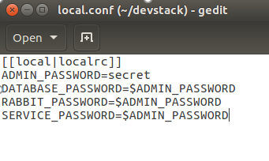

* This will run a series of scripts and install OpenStack in the local environment, once completed successfully we get the following message

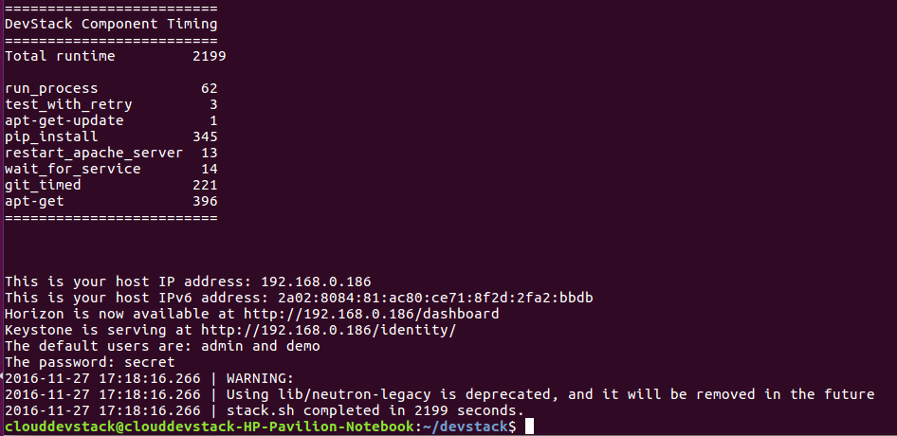

* OpenStack by default creates a host IP address, horizon dashboard and Keystone service URL’s and also creates an admin and demo users and their credentials.
* To test the installation we can login to the horizon dashboards (web interface)using the given credentials, notice that the URL is a local one created using Devstack toolkit.

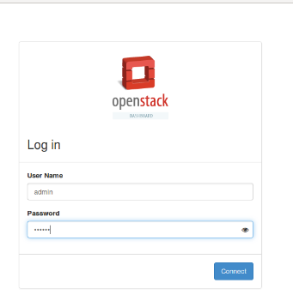 **Deploying an infrastructure over OpenStack**

We can essentially deploy OpenStack using two methods:

1. OpenStack Horizon Dashboard

2. Command line interface

**OPENSTACK DEPLOYMENT USING HORIZON DASHBOARD**

**OpenStack Admin can manage the following tabs:**

* **Project –** This tab is used to create new OpenStack projects, manage network topologies, maintain access and security groups etc. (however usually the tenants manage these features)
* **Admin –** Used to control and manage the cloud infrastructure such as hypervisors, aggregates of the host, flavours, boot instances, glance images, networks etc.
* **Identity -** As an admin one of the most important tasks is the identity management (Identity tab) to create an environment for the tenants to log in.

**Login as Admin user and create tenant environment(project):**

* Login using Admin credentials:
* Go to Identity and click on Projects.
* Create project and provide the project Quota ( to limit the access to the components within the cloud)

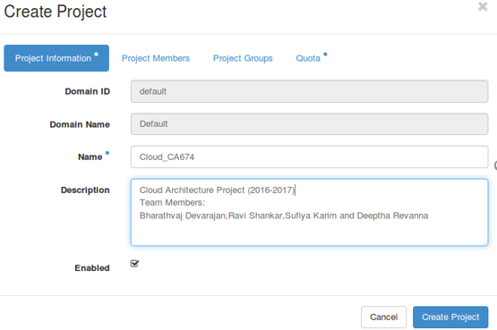

**Result: The project Cloud_CA674 was successfully created**

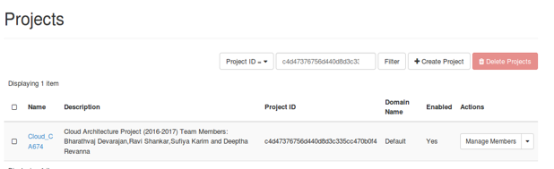

**Creating a user:**

* Go to User tab and click create a user.
* Specify the username and password.
* Assign user to a project and provide a role.

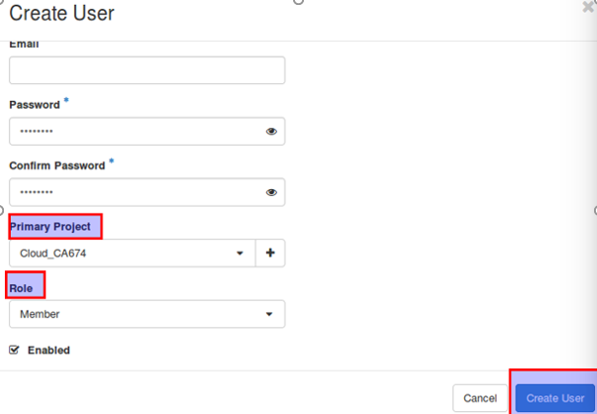

**Result: The user cloud sbrd was successfully created**

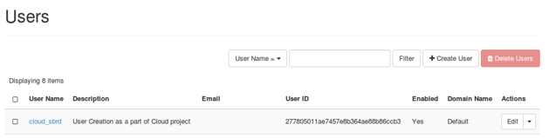

**Configuring Software Defined Networking:**

* Go to Networks tab and create an internal network and public network
* Provide network name, subnet name, subnet IP address range, allocation pool and DNS name servers (Allocation pool and DNS name servers only in case of internal networks).

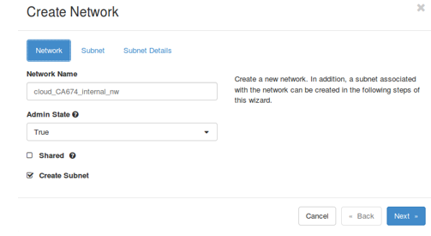

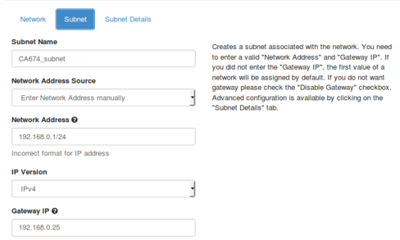

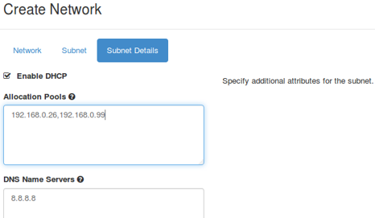

Follow the same steps for public network and disable the DHCP (as we won’t have access to all public IP address within the public network range)

Note: The Network address, Gateway IP and allocation pool IP address should not overlap. Also, to mark a network as an external/public network we need to log in as ‘Admin’, as changes to networks are in interference with the infrastructure.

**Result: The Internal and public SDN’s were successfully created**

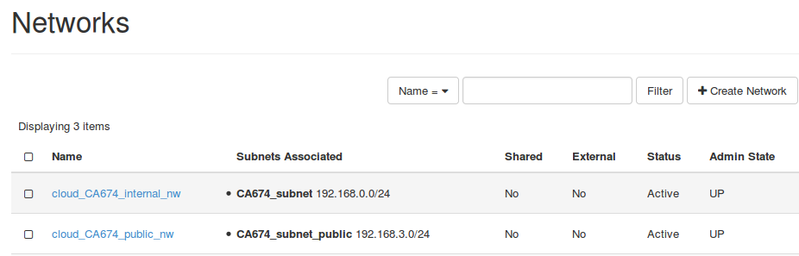

**Marking the created public network as an External network**

* Go to Admin->System->Networks
* Edit the network cloud_CA674_public_nw and mark as External

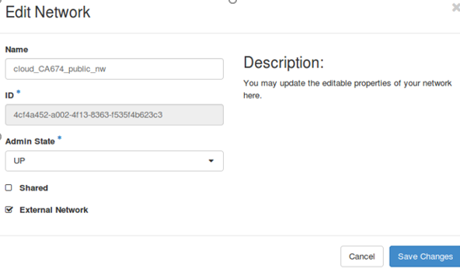

**Result: Network Changed to Public**

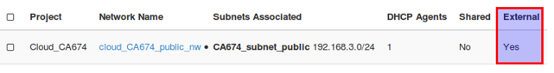

**Create routers which interface public and private network**

* Log in as a user and go to Networks->Routers.
* Create router by selecting the public network which we created.
* Edit the router to add an interface to the private network.
* Check the network topology to ensure that the router interfaces the public and private IP’s

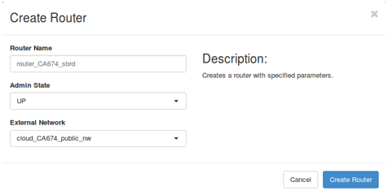

Edit Router to add interface to internal n/w

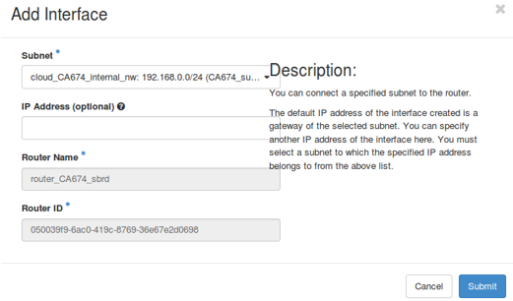

**Results: The router was created which acts as an interface between public and private network**

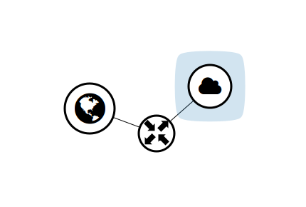

**Deploying an instance**

**Creating a Security Group**

These are required to defined the Firewall rules which are applicable to the deployed instance. We need to create these as the default security group only handles outgoing traffic (egress traffic).

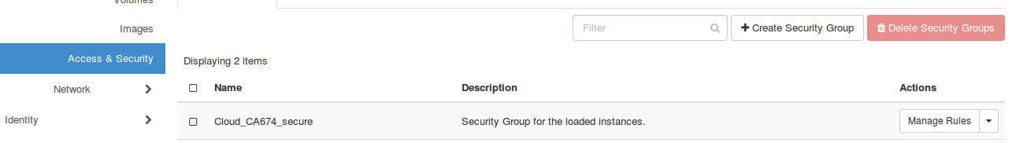

Go to Access and security group and create a security group

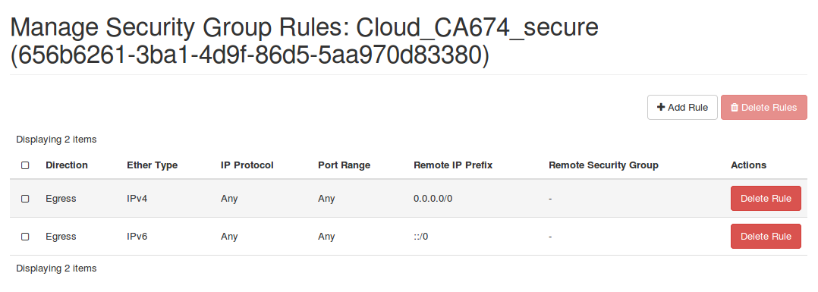

When we go to Manage Rules, we will see that the Egress rules are there by default

We can now add security rules for incoming traffic(Ingress) by clicking Add rule

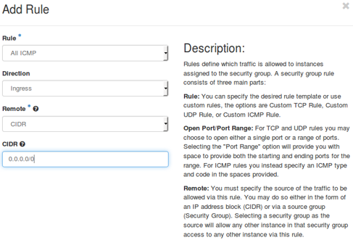

CIDR :0.0.0.0/0 denotes that anyone can reach the Virtual machine we are deploying

Similarly, we create rules for HTTP, SSH

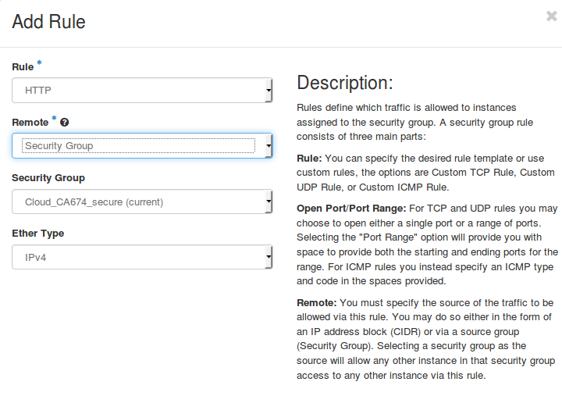

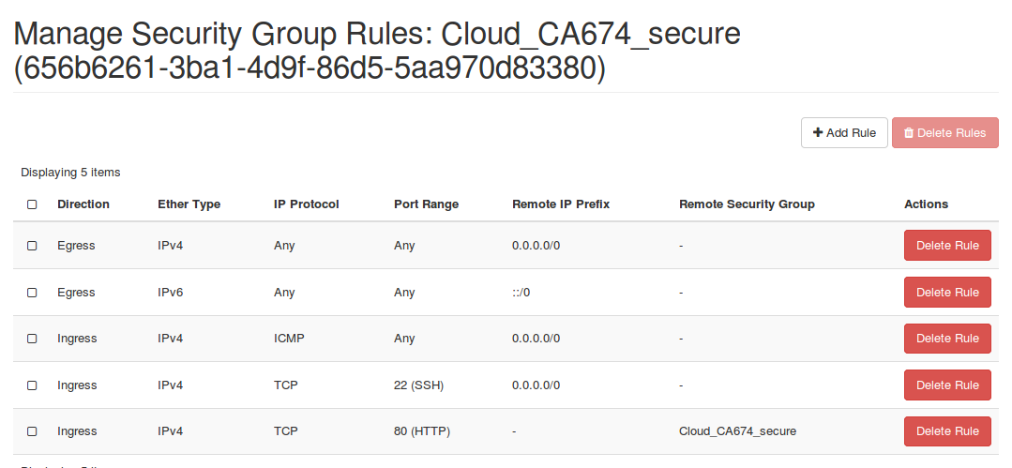

Create SSH Key Pair: These are downloaded into the local system when created

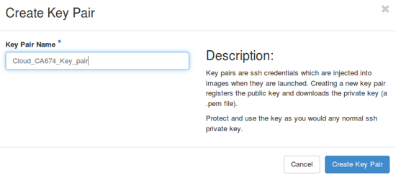

We can allocate the floating IP address from the project quota from the floating IP’s tab under Access and Security tabs

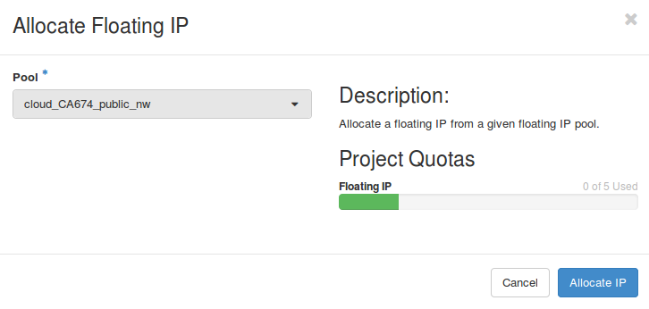

Allocated IPs

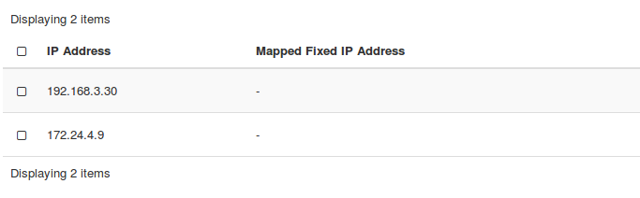

**Creating an image**

In the images tab, we can create an image to deploy the instance, for testing the infrastructure we downloaded a mirror test image and deployed it to OpenStack.

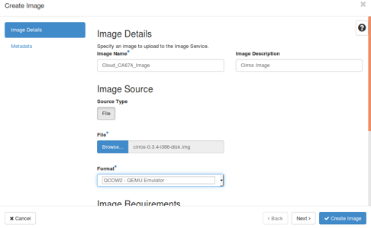

**Result: The image was created successfully by logging in as an admin user.**

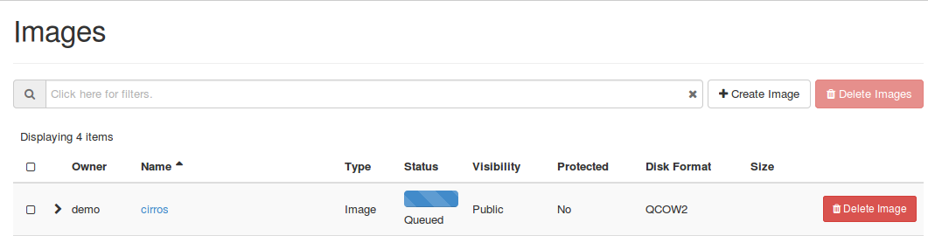

**Launching an instance**

While launching an instance, we must allocate all the resources which we built earlier

* Name the instance(Cloud_CA674_Virtual_Machine)
* Source: We allocate the image we created (Cirros Image)
* Select the flavour (t1.tiny)
* Select the network (Internal network)
* Select Security group(Cloud_CA674_secure)
* Select Ssh key pair(Cloud_CA674_Key_pair)
* Launch the instance

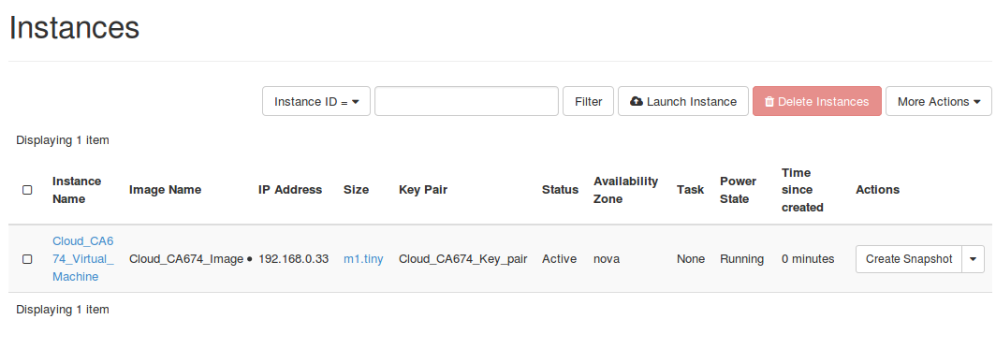

To make this Instance accessible from the outside we need to allocate floating IP address to it.

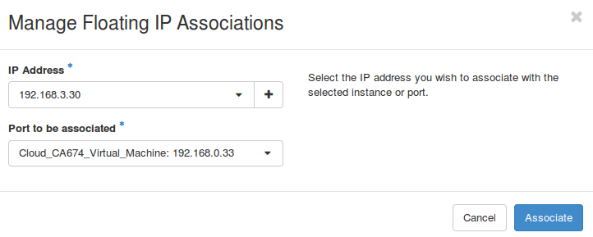

Launch the Virtual Image to load the Virtual Machine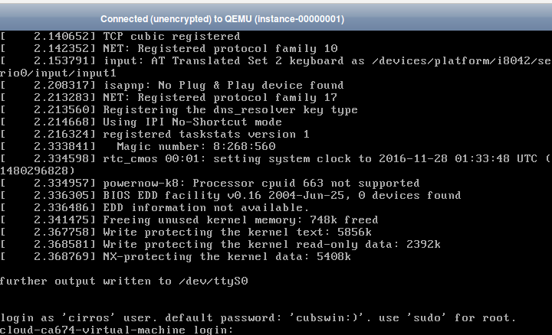

Error Encountered:

The keystrokes were not getting recognised by the system, it’s a standard bug in OpenStack.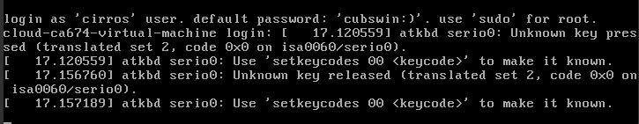

Bug details: <https://bugs.launchpad.net/nova/+bug/1621257>

**Add Volume to the Instance**

1. Go to Volumes and click create Volume and specify the Below Mentioned parameters to create a Volume.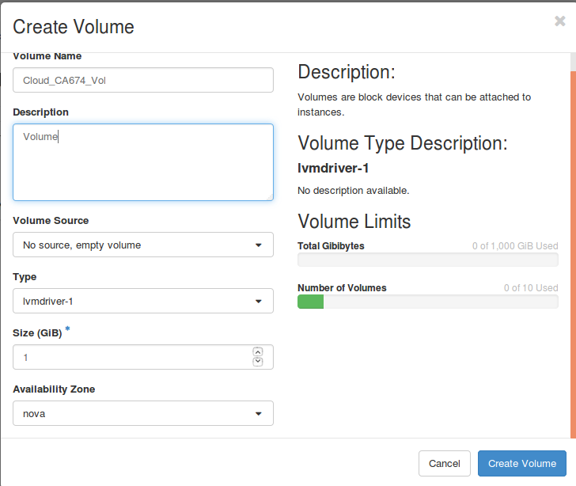
2. Once the volume is created we manage the attachment to attach the volume to our instance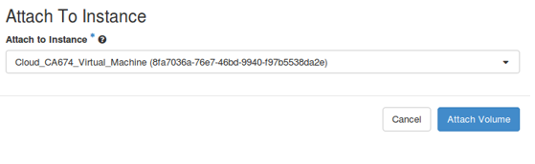

**Overall Usage Summary:**

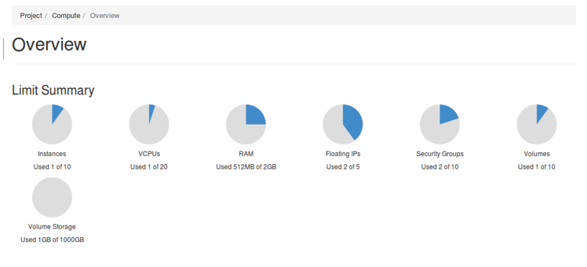

**Command line**

For OpenStack to identify the user role, the credentials should be passed in each command, which is cumbersome. For this, we can create a credential file which can be used to source the credentials.

So, the first step would be to create a keystone, admin file (Credential file)

1. Go to root directory and create a file with the following commands

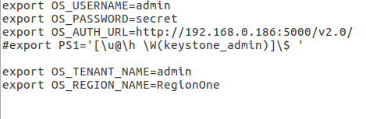

1. Go to command prompt and navigate to DevStack directory and source the credential file

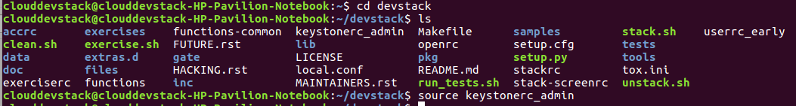

1. Check the existing OpenStack images, projects, and users

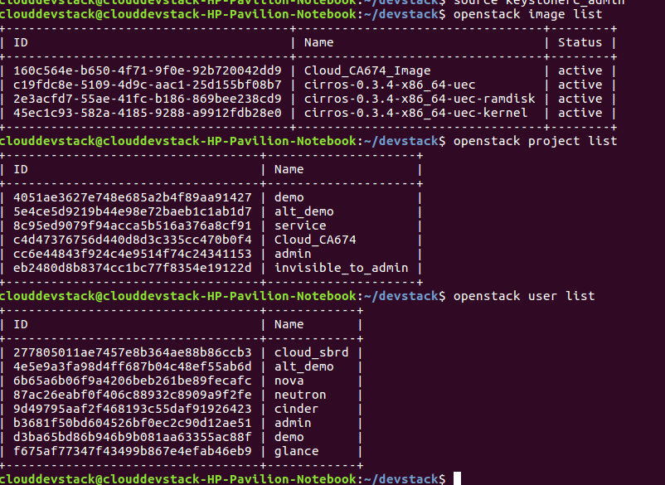

1. Now, like admin user we need to create the credential file for tenant user as well, for testing, we will run a ‘nova list’ command to check the instances running under that user.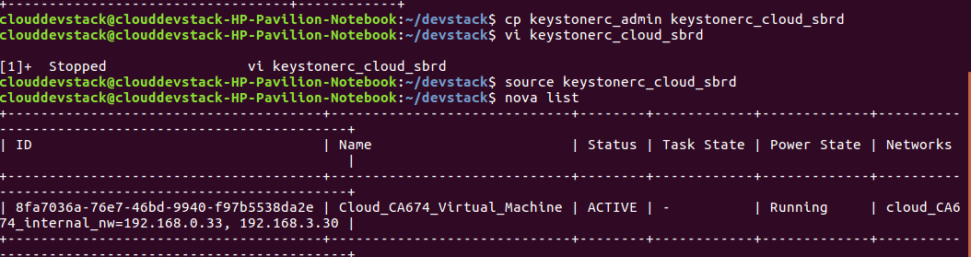

The output indicates that the user credentials are successfully created (as the Nova instances are invisible to the admin and visible only to the tenant users)

**Operations using Glance Image**

1. Get the glance image online (in our case we downloaded the Cirros OS)
2. Run the Glance command by specifying various parameters such as memory, visibility, disk format, container format etc.

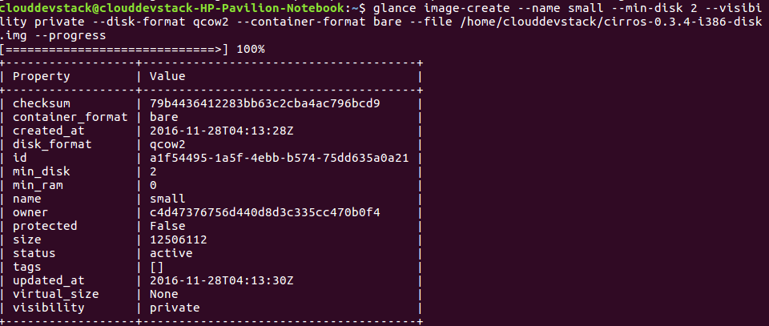

These entries are basically written to Maria DB database, with Glance image-list commands we can validate that our image has been created

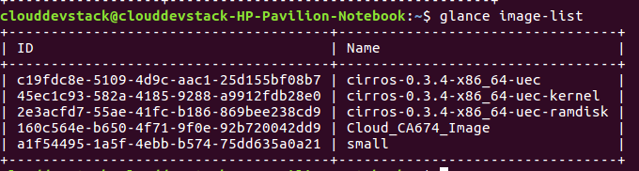

Deleting an image is possible by the command: **glance image-delete id**

where ID is the Glance ID of the image, for ex to delete the ‘small’ image the command would be

**glance image-delete a1f54495-1a5f-4ebb-b574-75dd635a0a21**

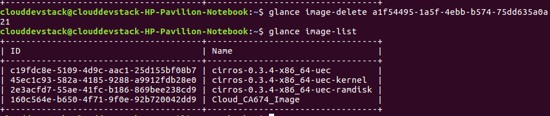

**Networking using Neutron**

1. Create a new subnet for the internal network cloud_ca674_internal_nw

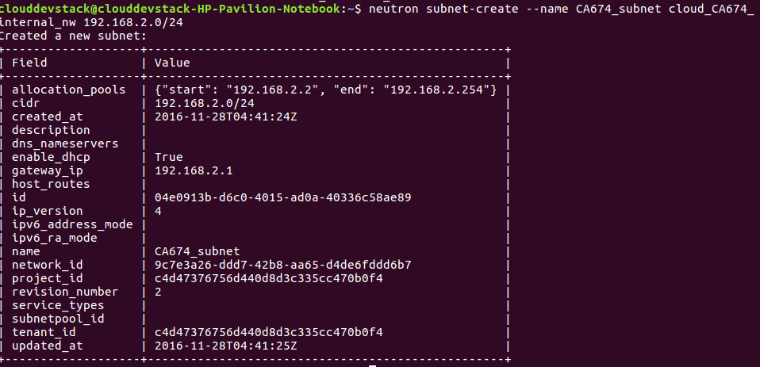

1. Interface, it with the router
2. Set router Gateway to public network

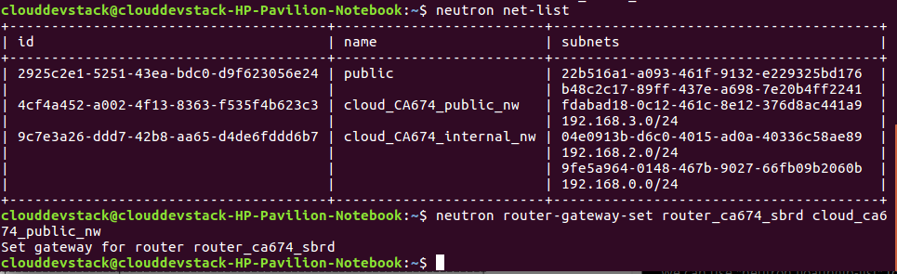

1. Setting the floating IP address

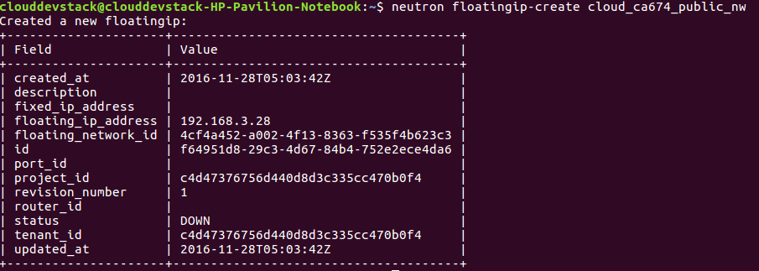

Network Topology (as visible in Horizon)

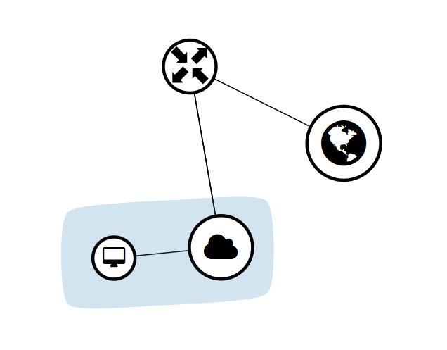

**Security Group and SSH keys**

1. Creating a new SSH key and security group

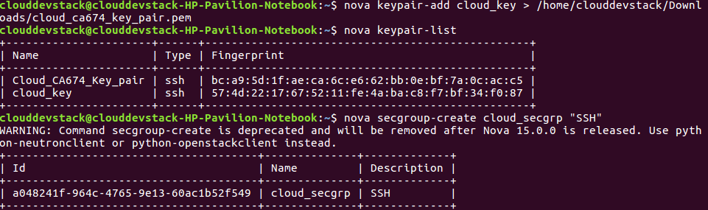

1. Adding Rules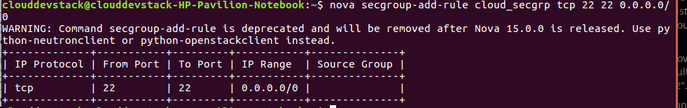

**Launching the instance**

As with Horizon, we need to combine all the resources we created so far and integrate it to run the instance.

1. List out the created sources

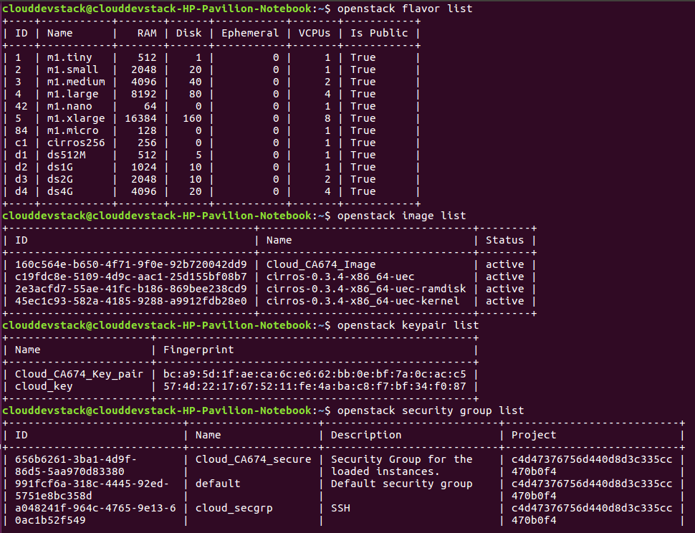

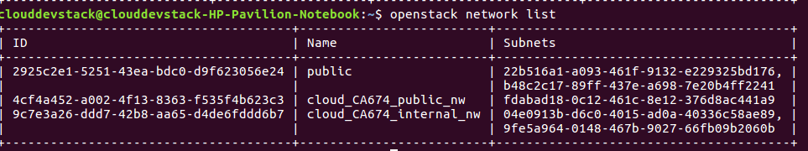

1. Make use of these information to create the instance

“**nova boot --flavor m1.tiny --image Cloud_CA674_Image --key-name cloud_key --security-group cloud_secgrp --nic net-id=9c7e3a26-ddd7-42b8-aa65-d4de6fddd6b7 cloud_instance**”

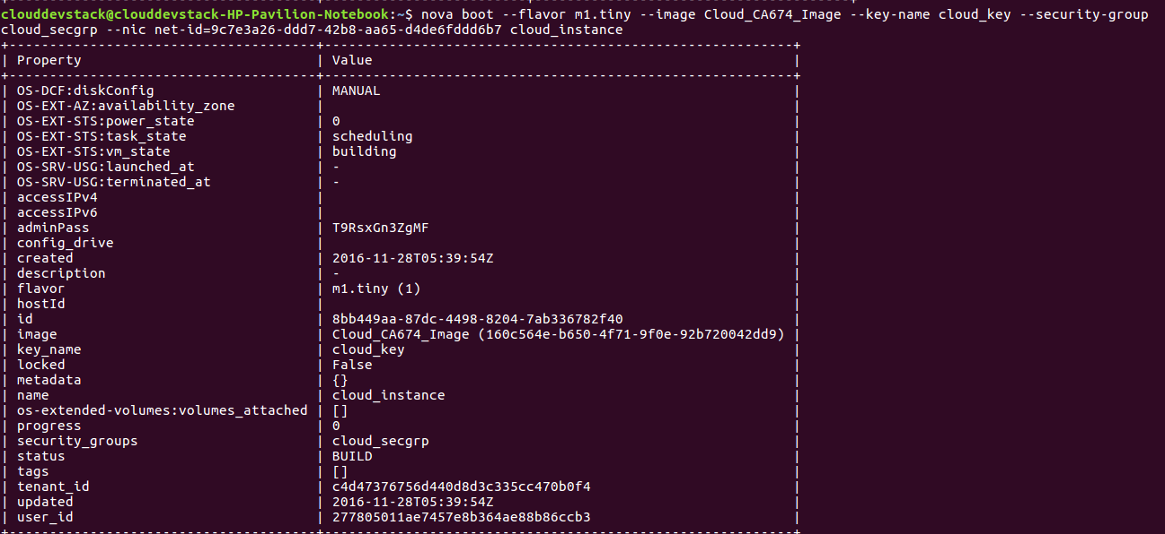

With Nova List, we can see that our instance is now Active and running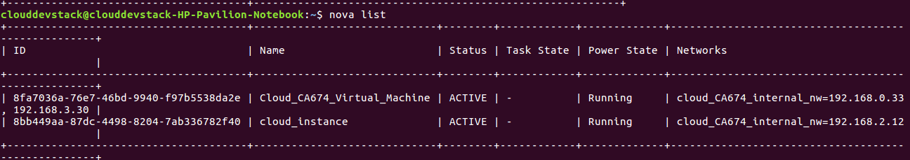

Running the instance using SSH key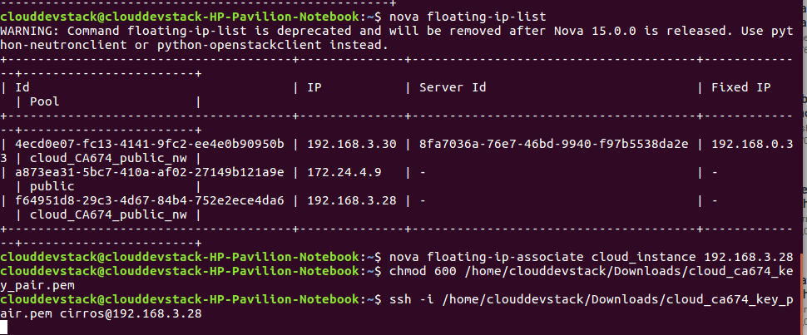

Failed with error: **SSH: connect to host 192.168.3.28 port 22: Network is unreachable**

The same instance boots when trying to load from Horizon.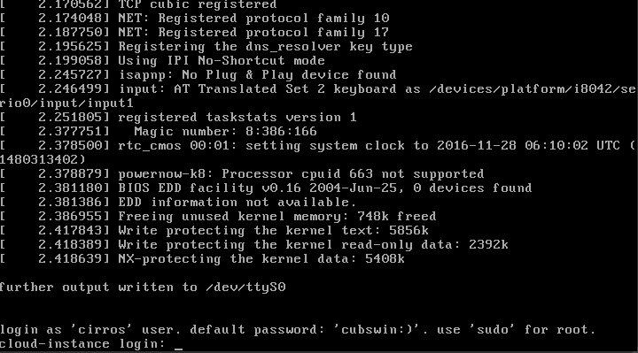

**Network Topology over Horizon**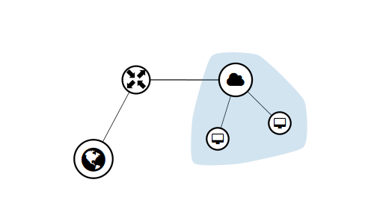

**OpenNebula Deployment**

OpenNebula can be installed in many ways I have selected Amazon AWS sandbox. Sandbox consists of Ubuntu 14.04 virtual machine image with a pre-configured OpenNebula 5.2.0 front-end a virtualization host.

**Steps involved in the installation of OpenNebula**

**Create your account in Amazon AWS**

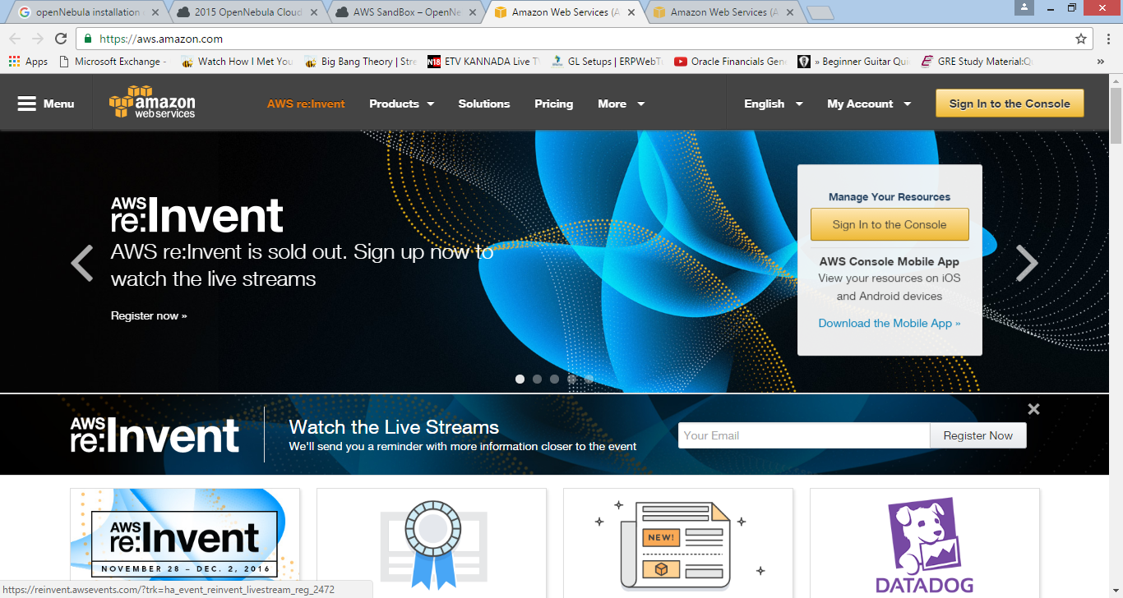

**Click on Sign-in to console**

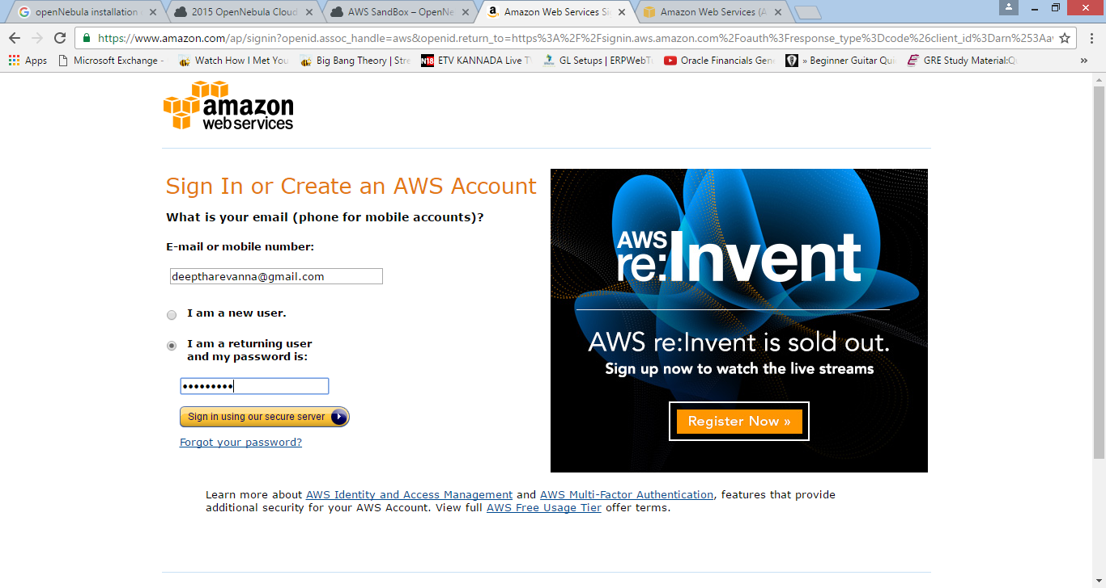

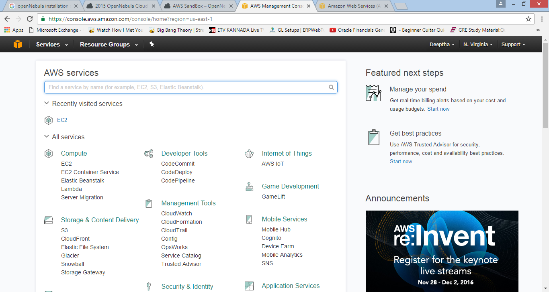

We need to create SSH key pair. Follow the below for the same.

**Click on EC2**

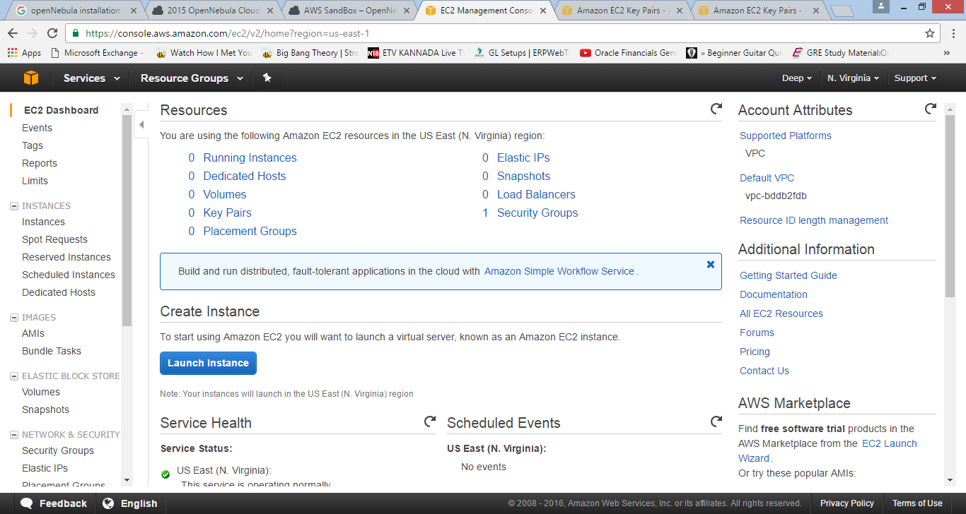

**Towards the left of the console go to the Network and security and choose key pair**

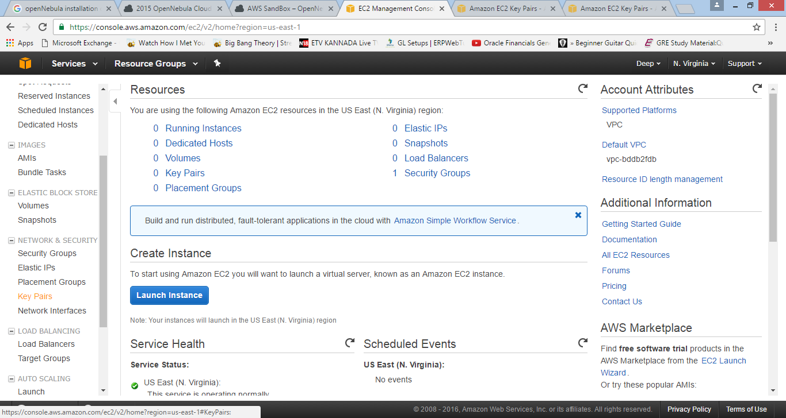

**Click on create key pair**

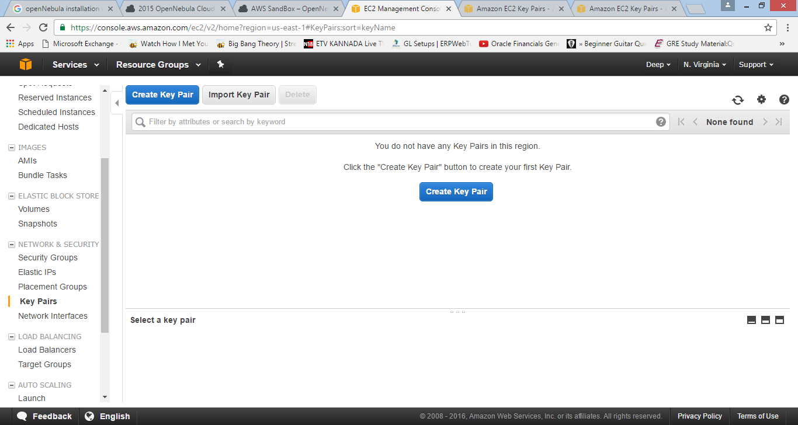

**Click on create**

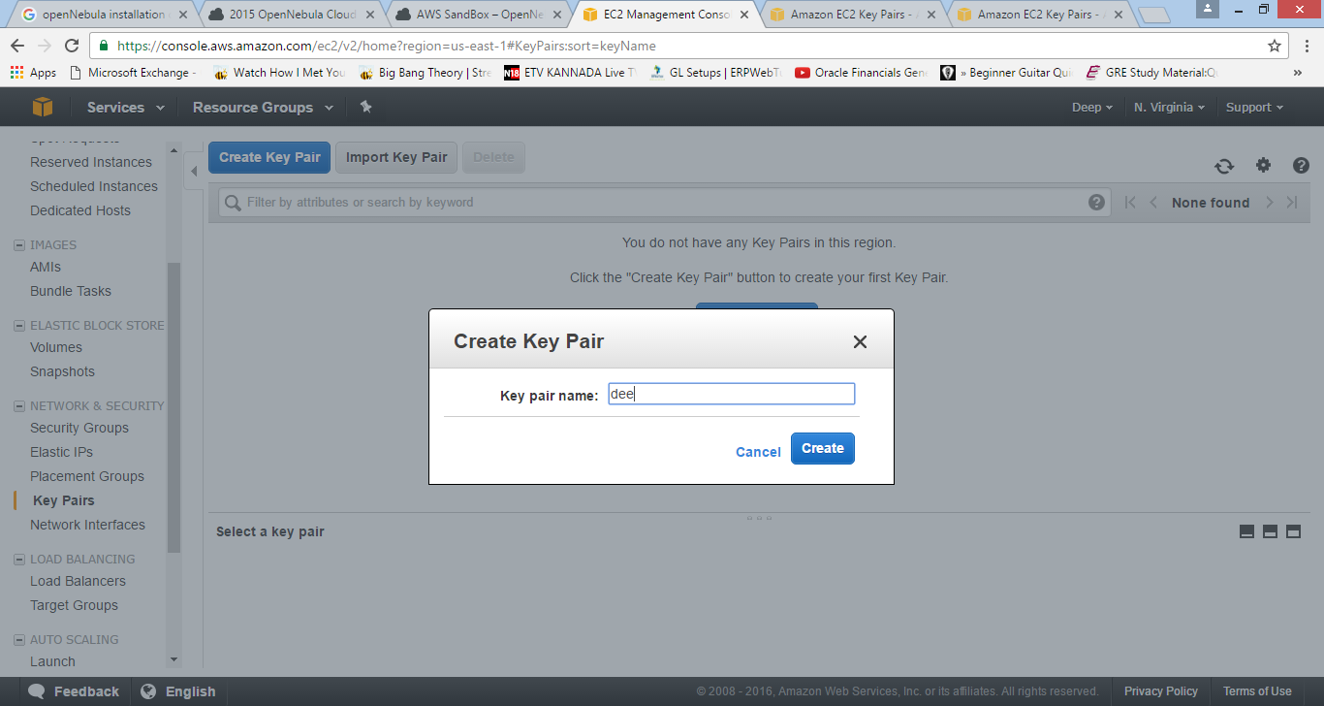

.pem file will get downloaded automatically

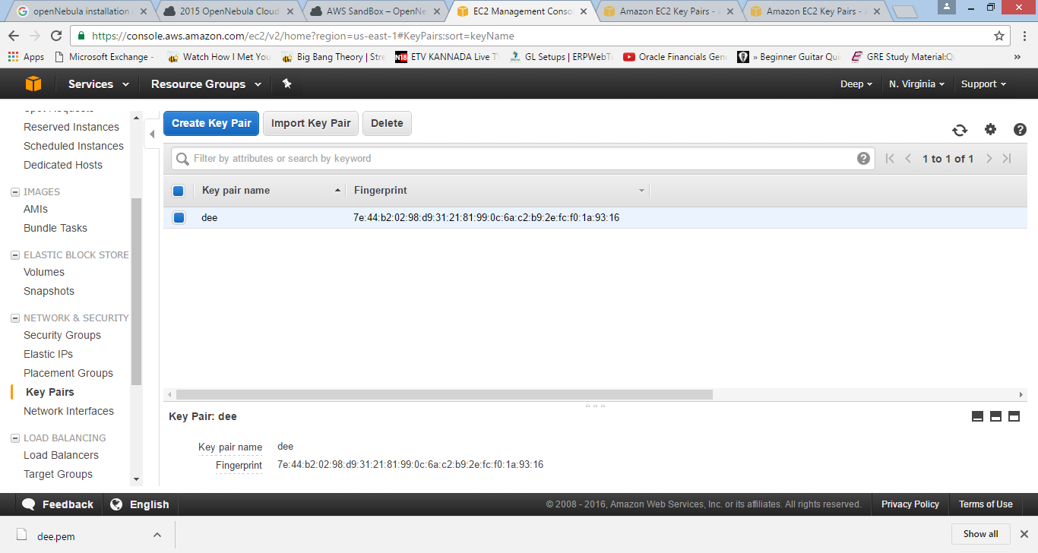

Go to the EC2 dashboard (you can see that in the navigation console)

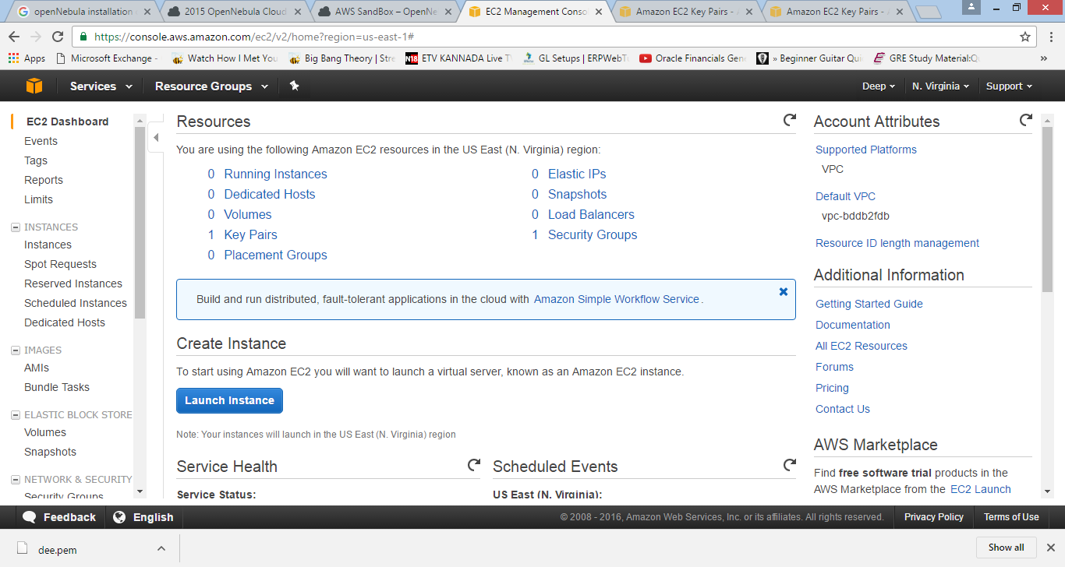

**Click on launch instance**

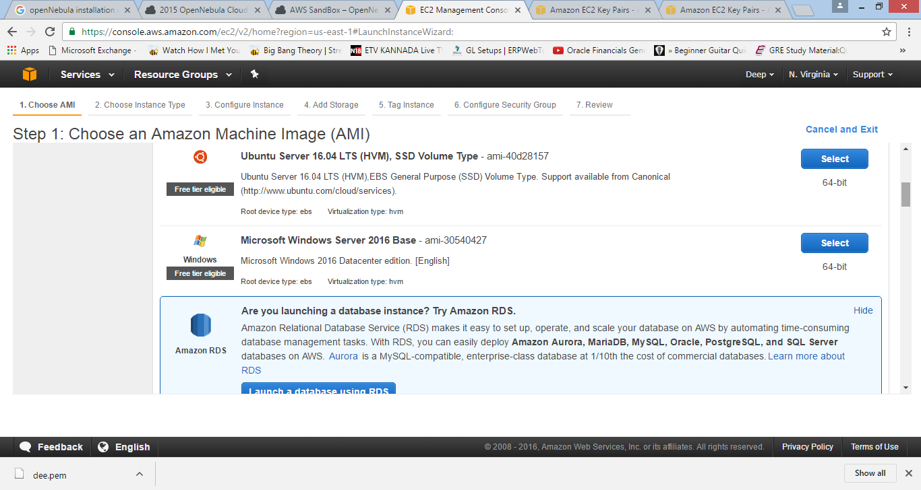

**Select the OS (Ubuntu server)**

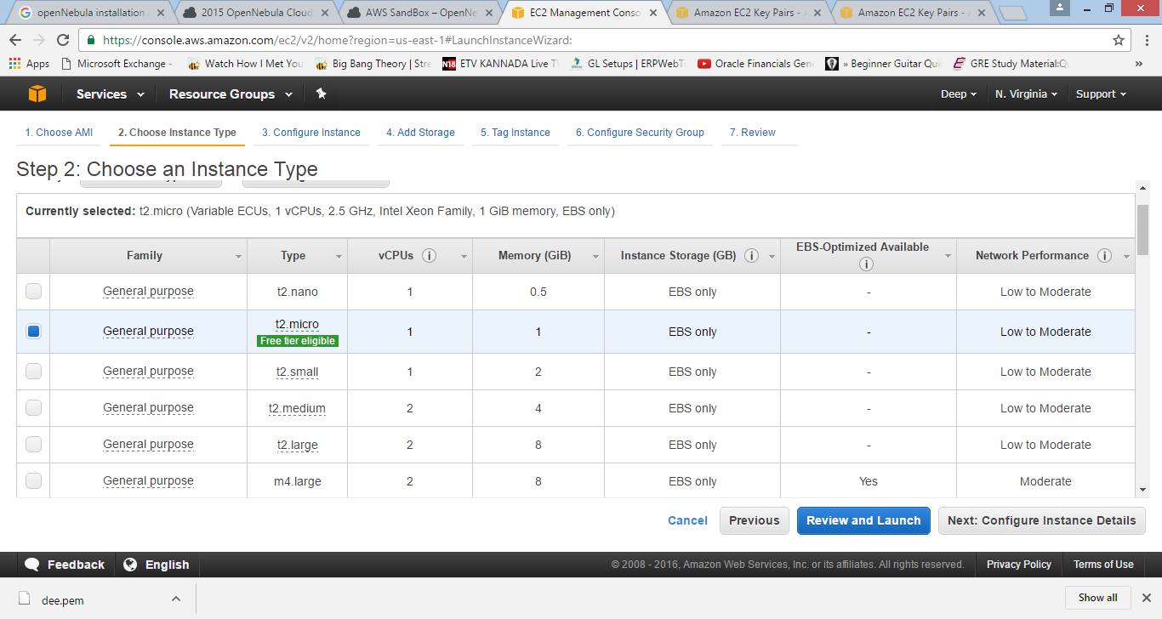

**Select the instance type (only the green highlighted one is for free)**

Click on review and launch

Click on launch

Click on launch instance

The instance will be launched. click on view instance

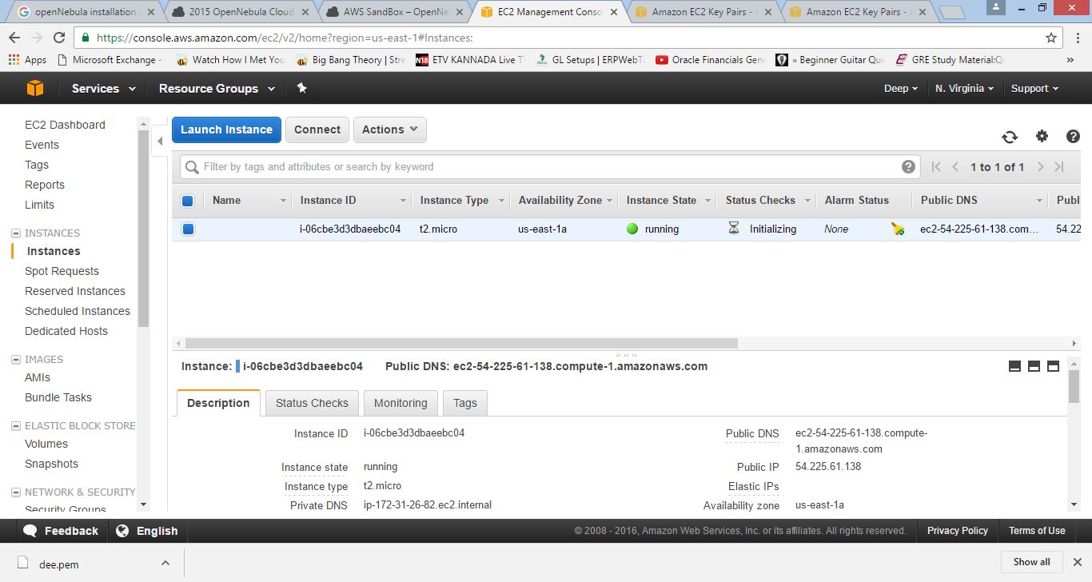

**To install OpenNebula**

1. Go to AMIs under Images
2. Search for ami-f53c1ae2
3. Click on launch
4. For that instance, go to the security groups -- launch wizard 2 and add the custom TCP rules

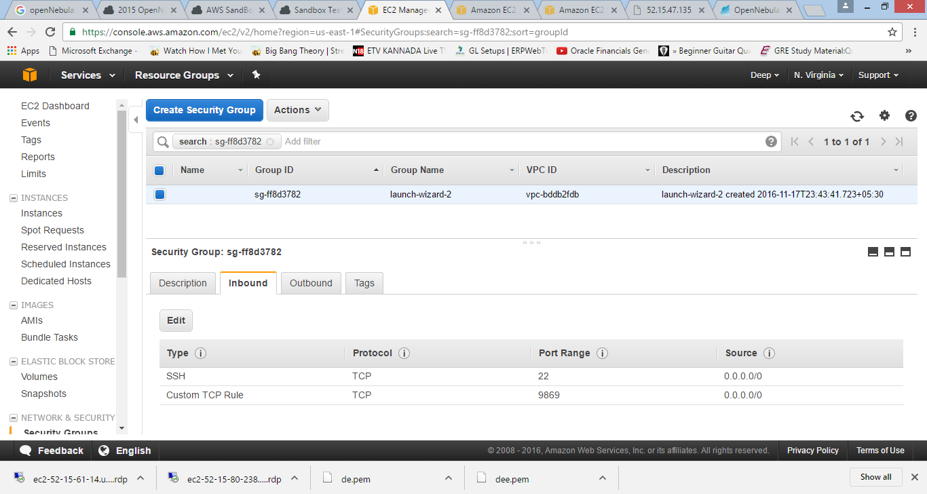

Go back take the public IP address

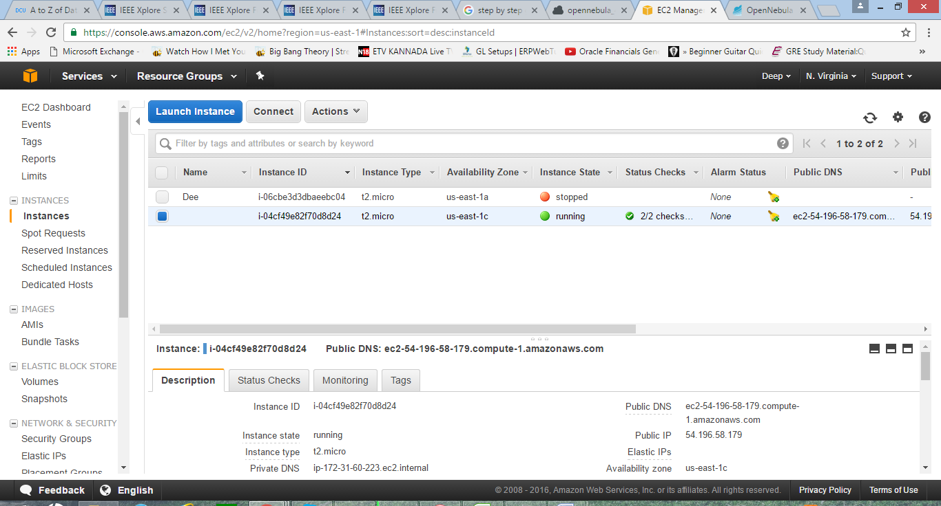

Add it to the browser along with the port :9869

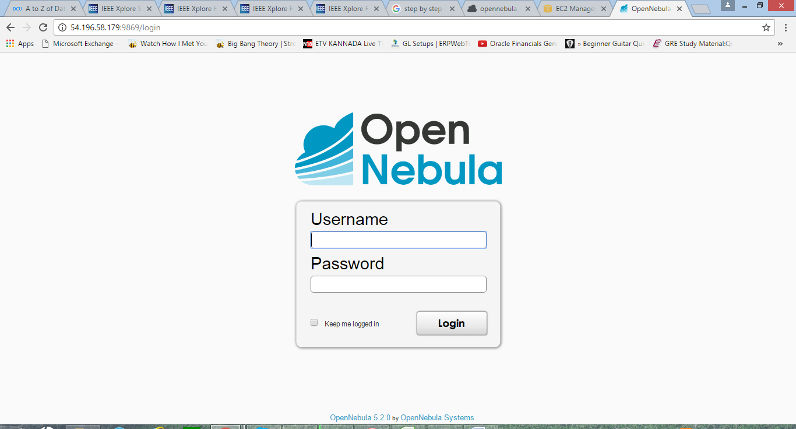

You will get the OpenNebula login page

Login using the login credentials

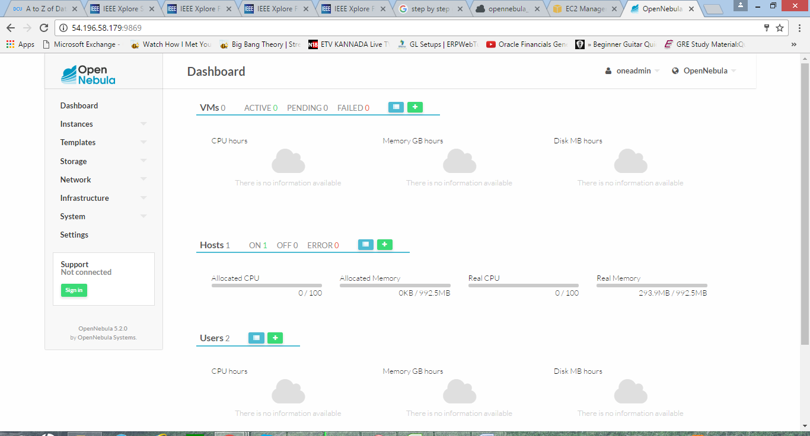

Add the host

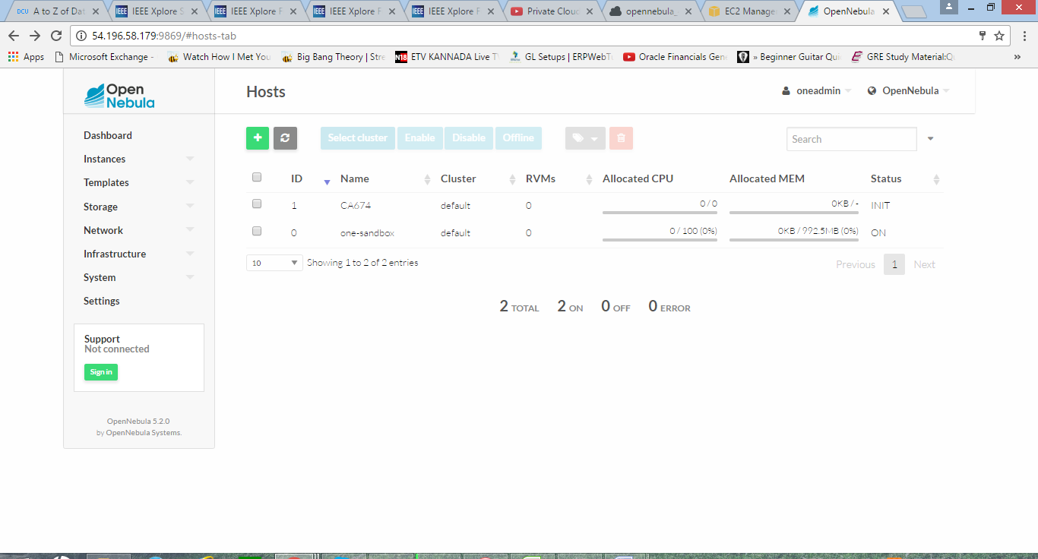

First, we will create a cluster web-dev where we will group the hosts, data stores and virtual networks for the creation of new virtual data centre.

**Go to infrastructure-> cluster**

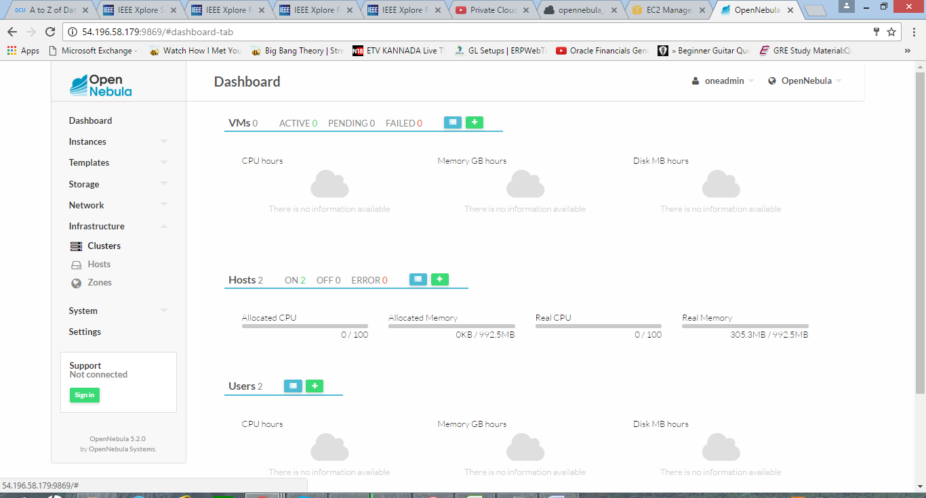

Click on create

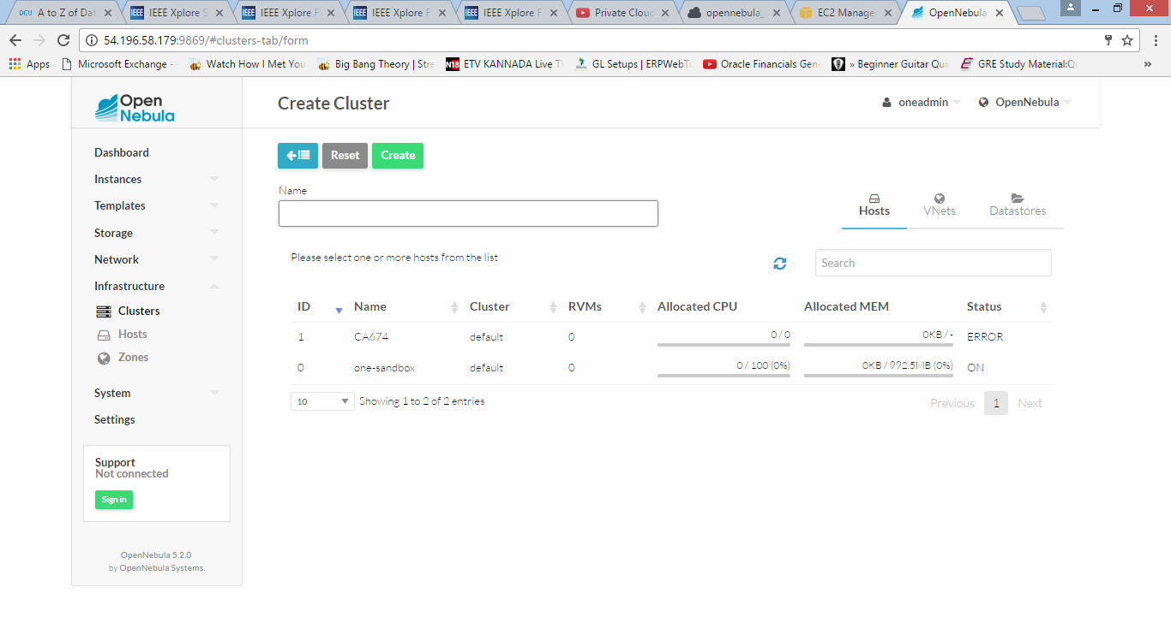

Create group

A new group by the name of 'web-dev' is created and a special admin user by the name of 'web-dev-admin' is added. The admin user will have the permission to create a new user in that group.

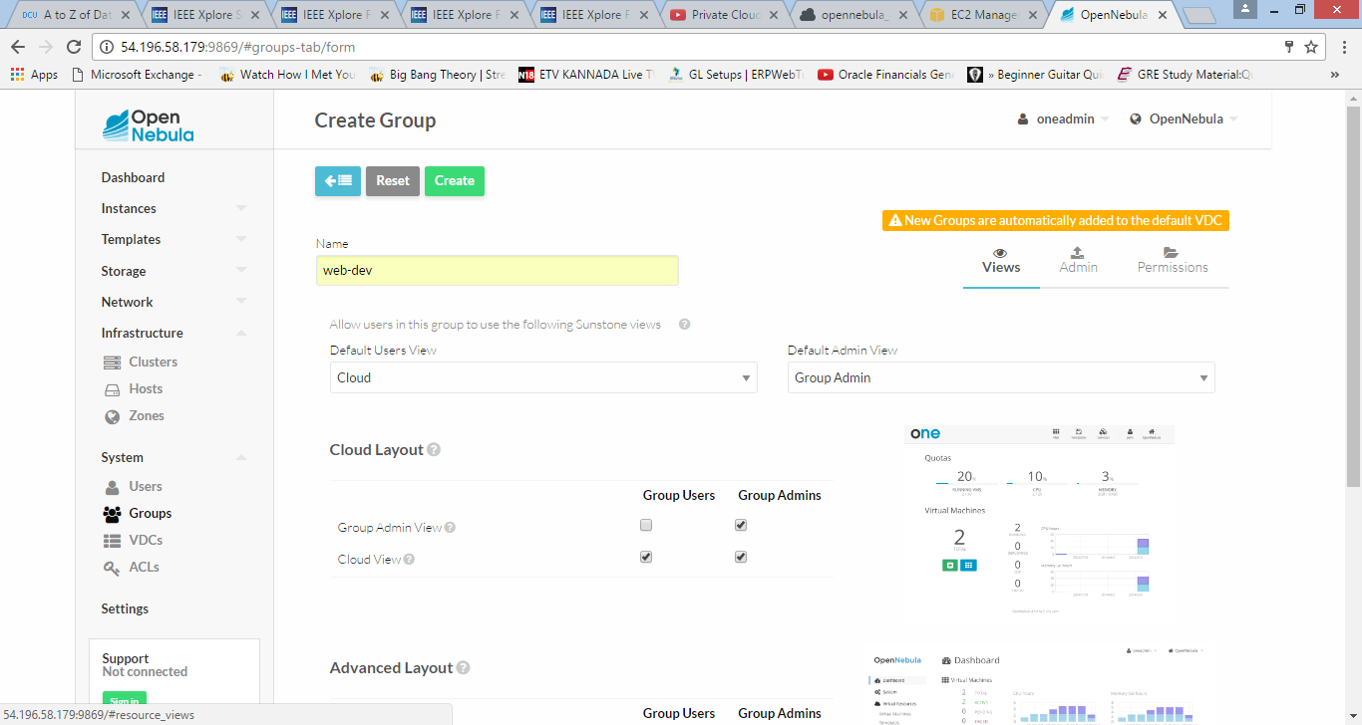

Create admin under the newly created group

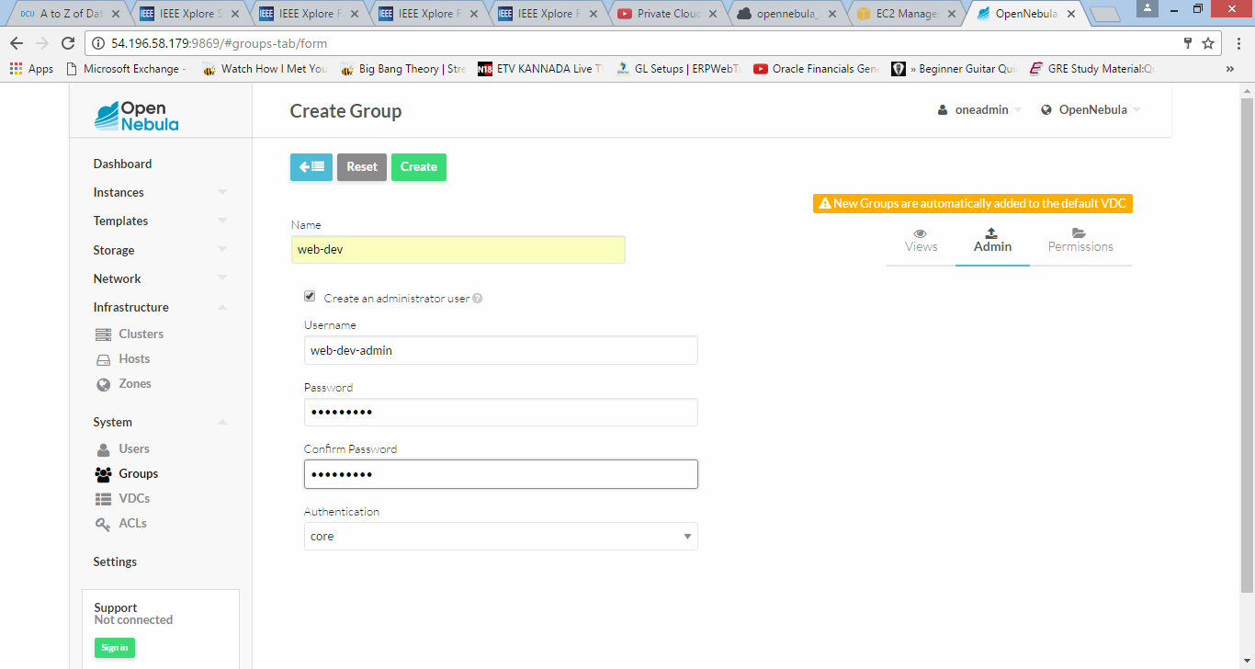

Click on create the group will be created

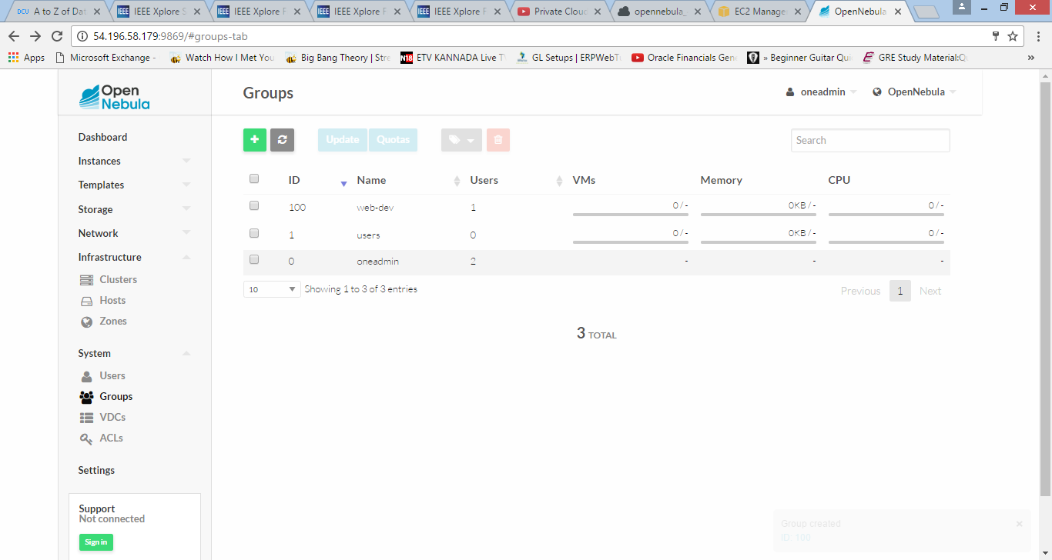

Creation of Virtual data centre

The name of the new VDC is given as 'web-dev'

Select the group created under the tab Groups

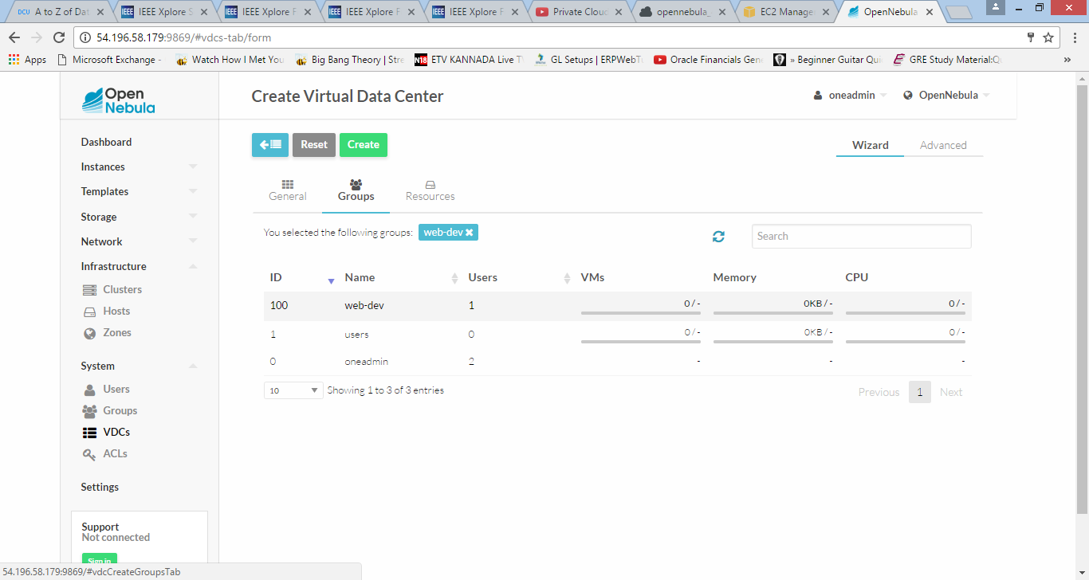

Select the cluster created under the tab Resources

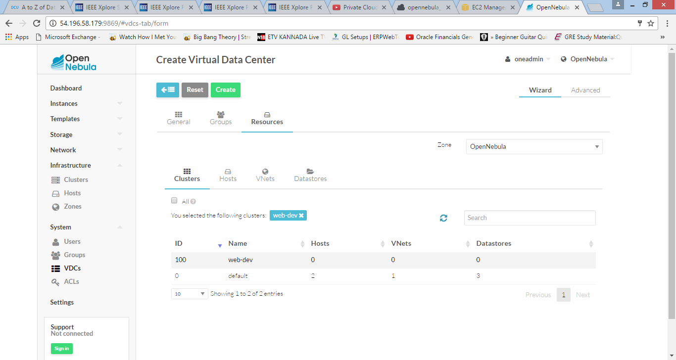

Click on create

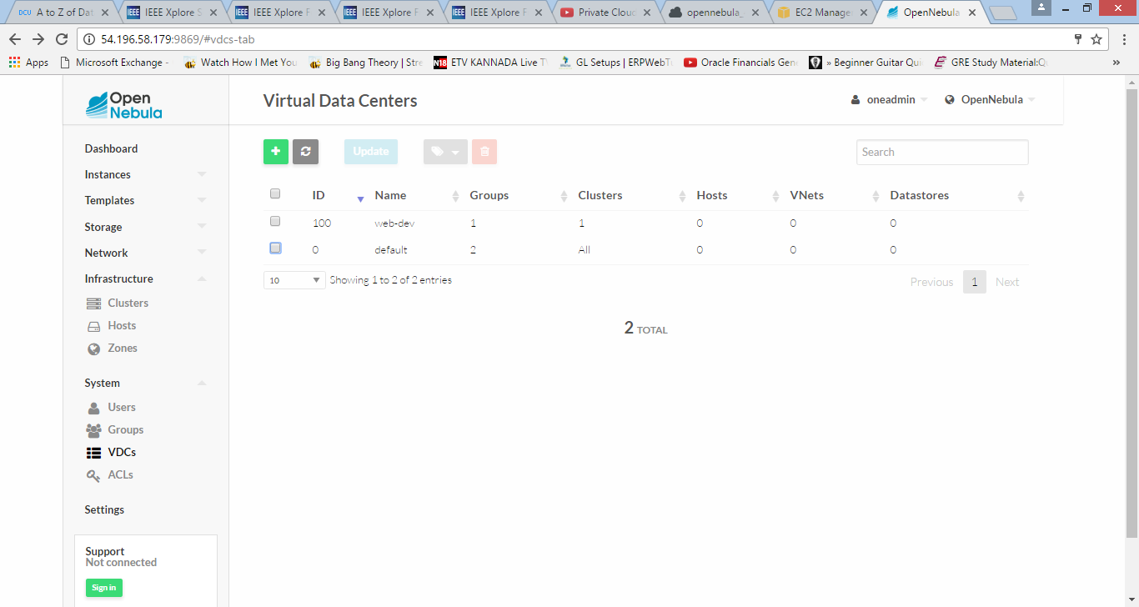

By selecting the group created and quota options in that we will be able to add and manage the resources

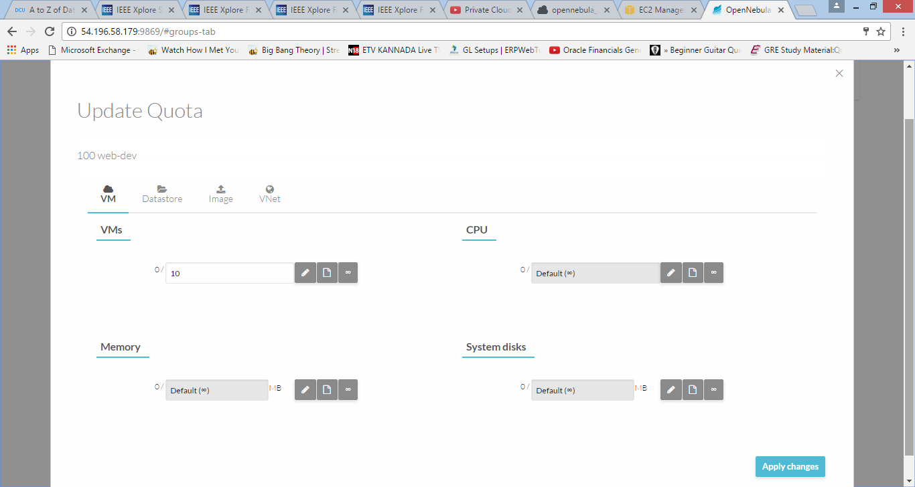

Click on apply to see the changes

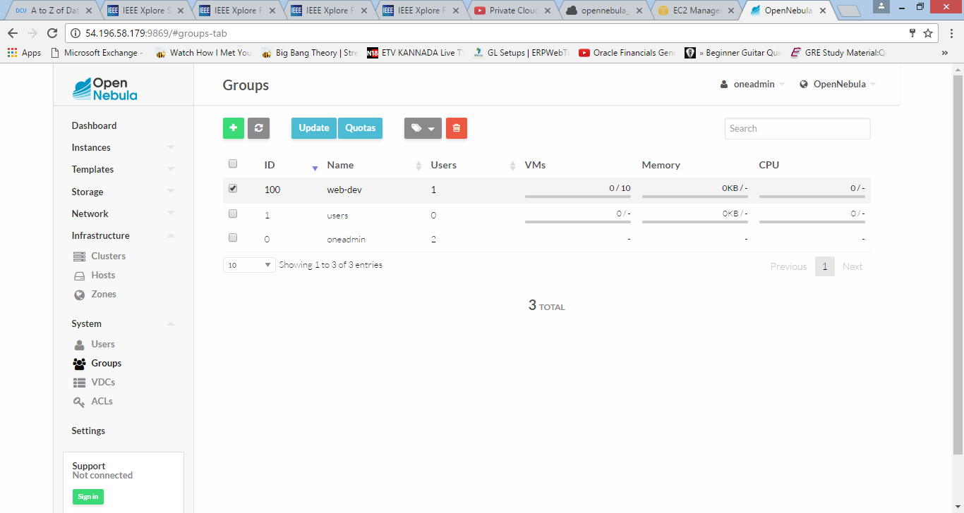

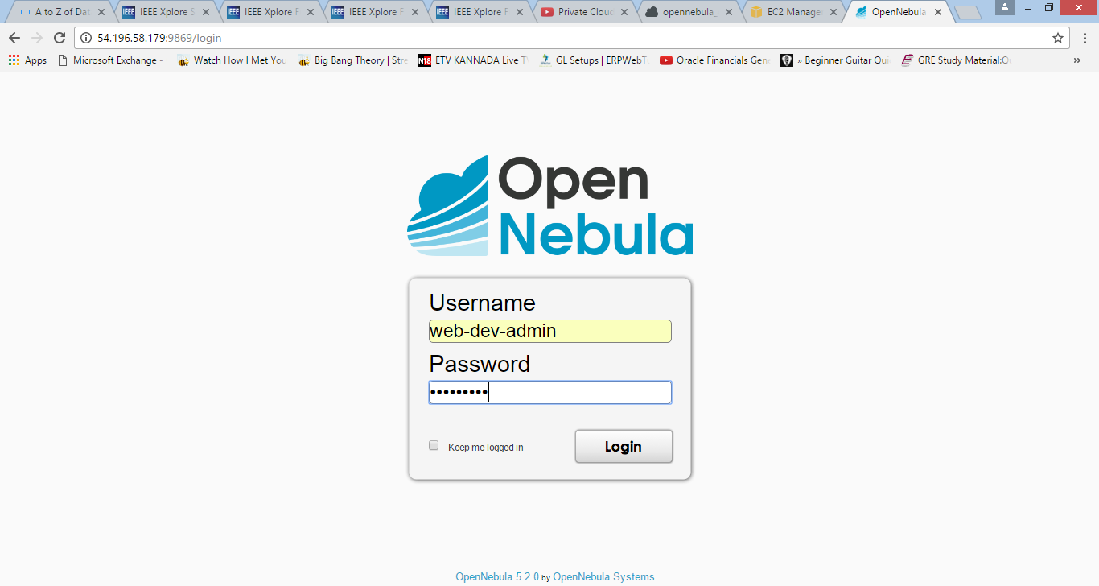

Now log in as an admin user to check the difference it will be a simplified interface compared with the group admin view

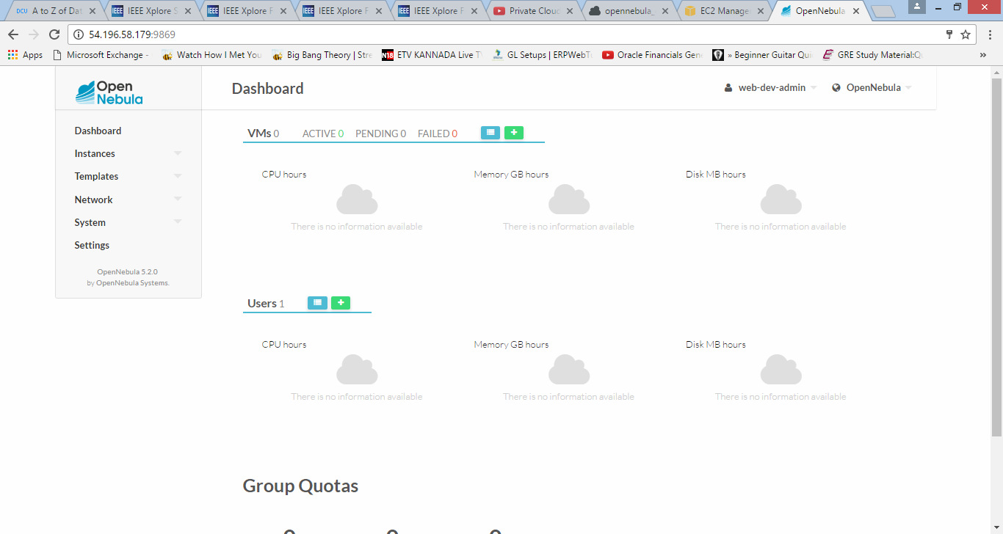

The admin will have the rights to create users allocate resources to them and has to provide the quota limits to each one of them

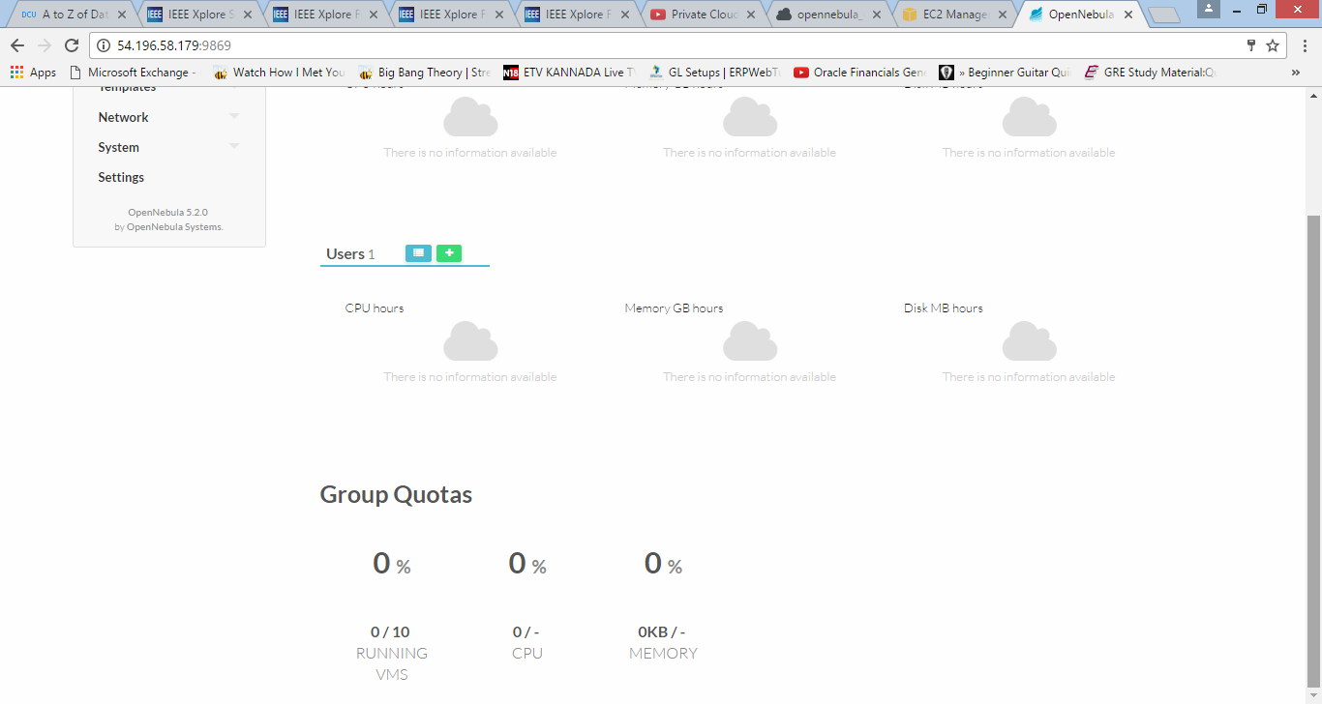

User created by admin under the same group

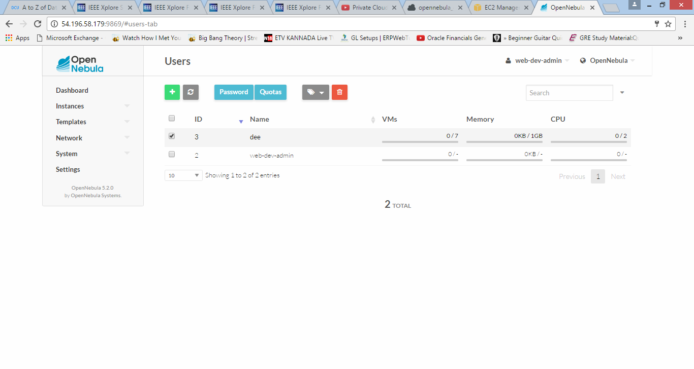

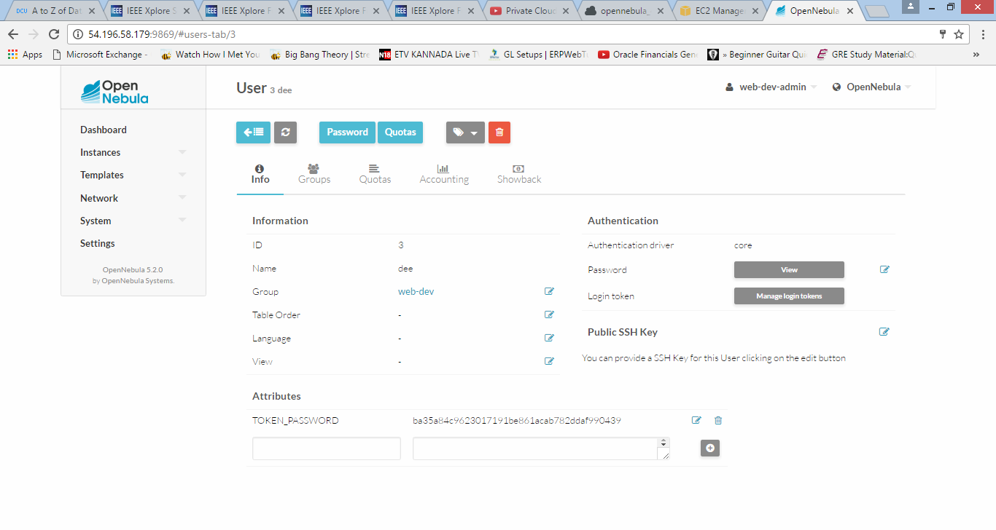

Log in as a User

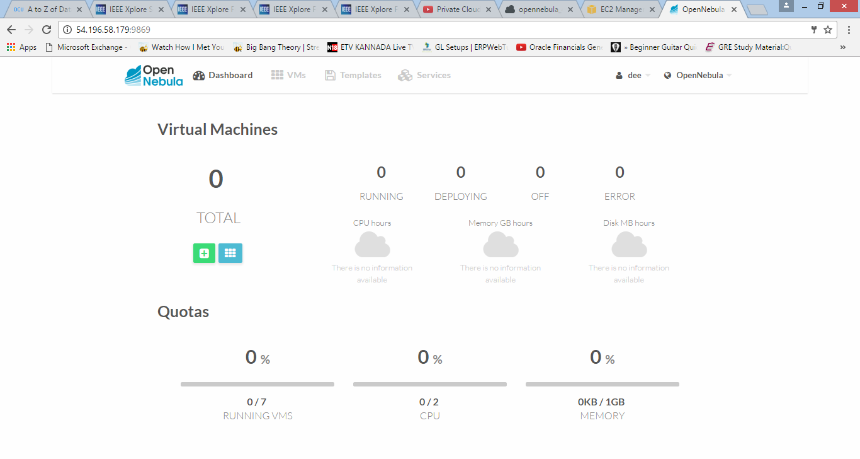

User will have the access to create the Virtual machine with the template provided by the admin

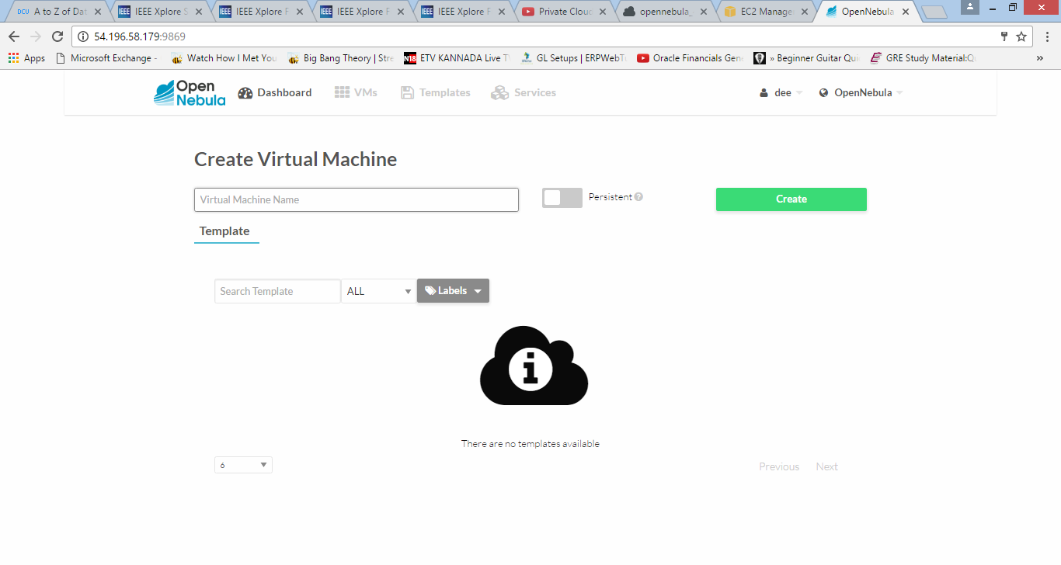

Login in as an admin to create the virtual machine

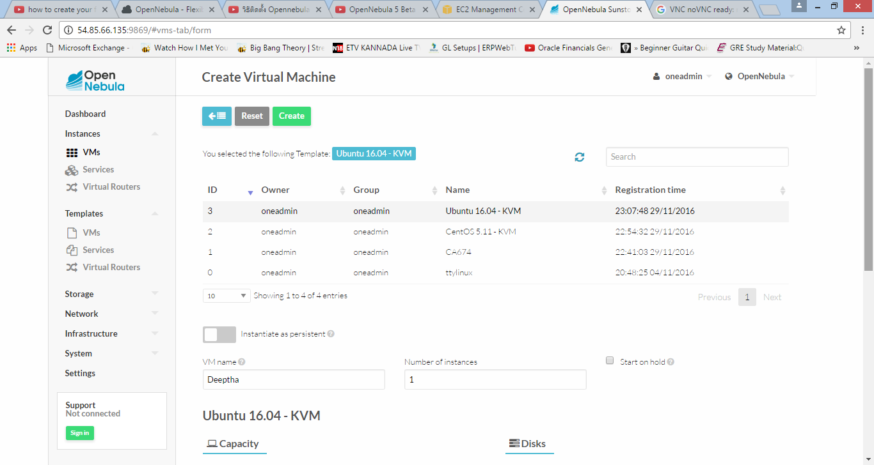

Select the template to create the virtual machine using ttylinux-0. Give the name to the Virtual machine and click on create

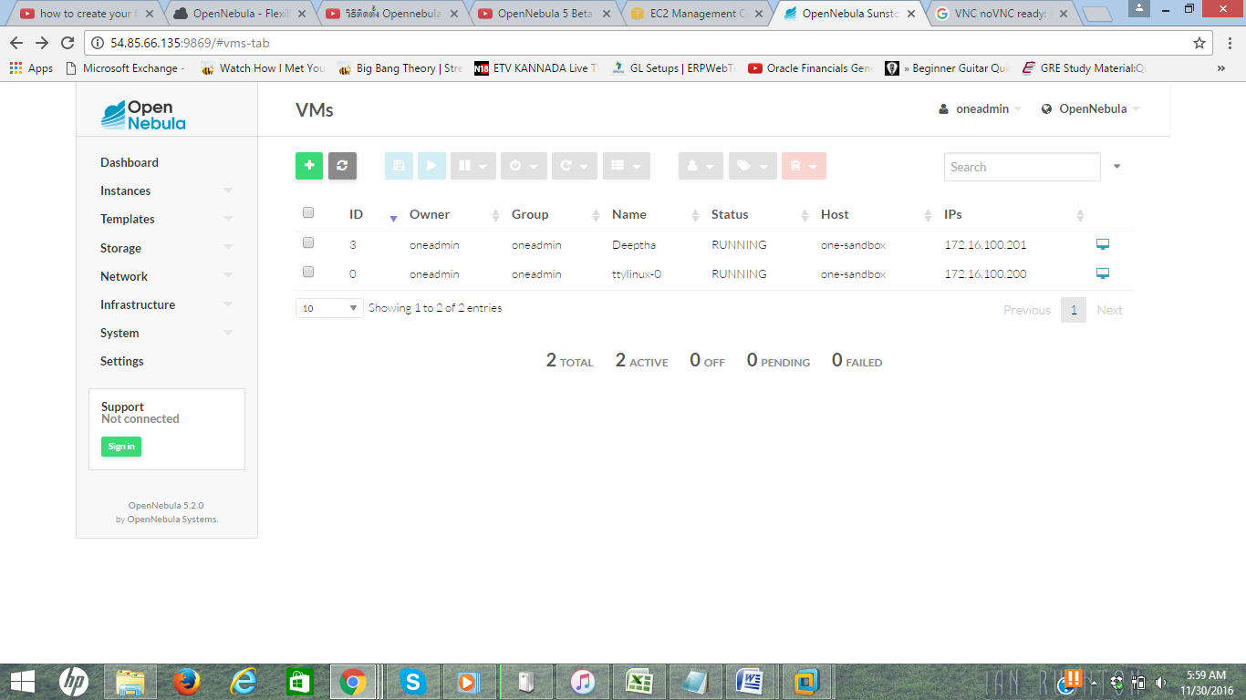

Thus, the Virtual machine becomes active changing the state from Pending to Running

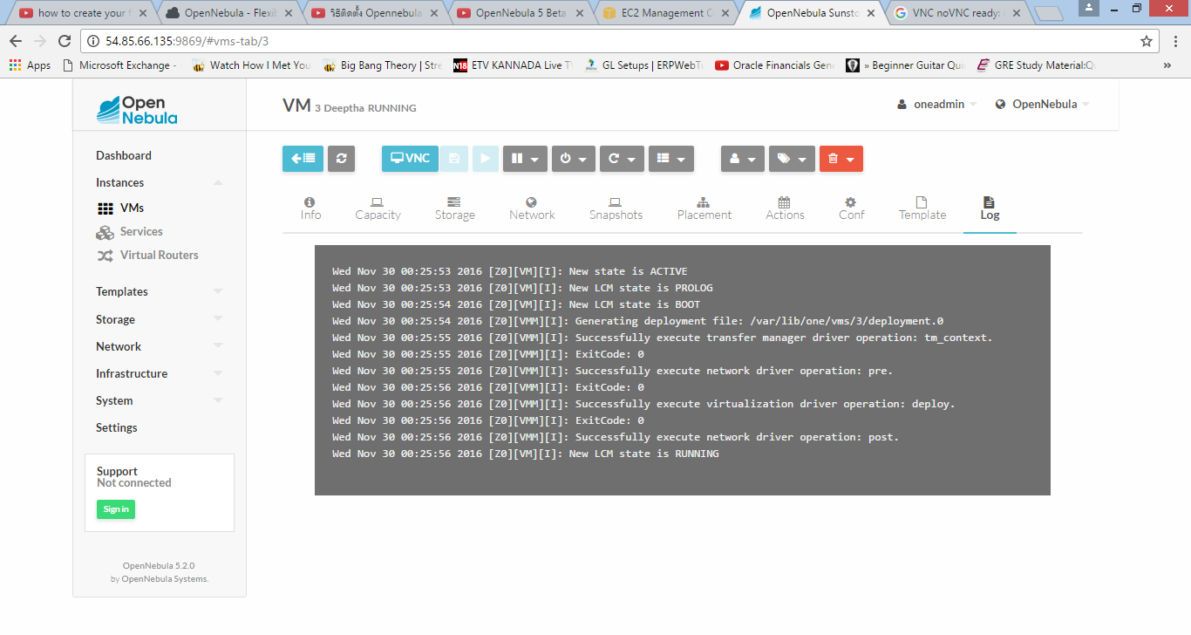

**Comparative Review**

* **Interoperability – OpenStack** consists of a massive community of active users and has an edge over other cloud technologies when considered a long-term option. From a technology perspective, few components of OpenStack are exceptional. The biggest challenge which OpenStack faces is that of the integration of several subprojects having an inconsistent level of maturity. It is also difficult to achieve interoperability when private and public cloud models are concerned. Proprietary hardware has been a bottleneck with various cloud platforms which has been taken care by Openstack as it uses a wide range of vendors. It is completely interoperable with clouds powered by Openstack and semi-interoperable with Amazon EC2.

An **OpenNebula** server can also collaborate with Amazon EC2 and provide better interoperability as compared to OpenStack.

* **Scalability** **and Availability** – A cloud implementation is said to be scalable if it can assist user requests for sizeable proportion of cloud resources. The process of expanding **OpenStack** scalability is not an easy process as the segments which work in test sandboxes finds it hard to surpass early production and make it into large scale release. Many tools and vendor plug-ins are not quite scalable.

**OpenNebula** is designed to achieve high scalability by making its core daemon highly robust and scalable. The logical entities termed as clusters provide load balancing features in addition to high end computing and availability.

* **Security** – Security and vulnerability has been one of the major concerns of cloud based technologies. **Openstack** handles security in a procedural method as the community members report vulnerability to security.openstack.com so that they can be fixed. Certain APIs are offered by OpenStack that provides traditional security safeguards.

**OpenNebula** consists of a security system that provides a system of groups and users which provides security through authorisation and authentication. Security is based on X509 certificates and passwords are encrypted by SSA RSA keypairs.

* **Pricing** – **Openstack** billing is done by a tool called StackOps Chargeback which provides easy integration with various components and utilities of the datacentre. After gathering data from the infrastructure, the billing cycles are laid out on hourly basis.

Data usage is monitored in **OpenNebula** and is used in addition to billing and Chargeback solutions. **Eucalyptus** uses CloudWatch to gather relevant metrics about the usage of cloud resources which takes bandwidth, network traffic and resource usage statistics into account.

**Conclusion**

Our report is focused on the implementation of two IAAS cloud technology solutions – OpenStack and OpenNebula. The report reviews the core components of various cloud technologies including OpenStack, HPE Eucalyptus, OpenNebula and CloudStack and their individual component’s interaction with each other. The important functions served by these components have been explained along with the challenges they help us overcome. The cloud technologies have been differentiated based on their features and their pros and cons have been explained. It is followed by the installation steps and experimental evaluation of OpenStack and OpenNebula. The solutions are compared based on the services they provide such as scalability, availability, pricing, interoperability, and pricing. The next part of this report contains the deployment of two different cloud solutions namely OpenStack and OpenNebula. Lastly, the report contains the description of the development of a web app prototype called DCU Chat which allows DCU students to perform private messaging services. It also specifies the challenges faced by our group during various stages of the cloud solution installation as well as app development and integration.

We have gained valuable insight into the technical challenges of implementing tangible cloud solutions and understood about the scalability, interoperability concerns while installation and integration of the DCU chat web app.

**References**

[www.openstack.org](http://www.openstack.org)

<http://www.edx.org/course/introduction-openstack-linuxfoundationx-lfs152x>

<http://docs.openstack.org/juno/install-guide/install/apt/content/ch_overview.html>

<https://www.linkedin.com/pulse/cloudstack-v-openstack-good-bad-ugly-macalister-bali-mba>

<https://github.com/eucalyptus/eucalyptus>

<https://en.wikipedia.org/wiki/Eucalyptus_(software)>

<http://www8.hp.com/us/en/cloud/helion-eucalyptus.html>

<http://searchcloudprovider.techtarget.com/definition/Eucalyptus>

[www.opennebula.org/](http://www.openstack.org)

https://help.ubuntu.com/community/OpenNebula

http://archives.opennebula.org/_media/community:cloudcamp-valencia.pdf

http://www.geektantra.com/2014/10/opennebula-vs-openstack-vs-cloudstack

[https://www.OpenStack.org/software/start/](https://www.openstack.org/software/start/)

[http://docs.OpenStack.org/image-guide/obtain-images.html](http://docs.openstack.org/image-guide/obtain-images.html)

<http://download.cirros-cloud.net/0.3.4/cirros-0.3.4-i386-disk.img>

<http://opennebula.org/tryout/sandboxaws/>

<http://docs.opennebula.org/pdf/4.14/opennebula_4.14_design_and_installation_guide.pdf>

http://docs.openstack.org/arch-design/massively-scalable.html